**LunaH-Map**

*Lunar Polar Hydrogen Mapper*



**Mini-Neutron Spectrometer** **Interface Control Document**

**Mission Document ID:** LUNAHMAP\_PLD\_ICD

|  |
| --- |
| **WARNING**  This document contains controlled technical data as defined in the applicable U.S. Export Control Regulations. Export of this material is restricted by those regulations. This material is not to be exported to foreign persons without appropriate export authority (e.g., an export license or other approval issued by the U.S. Government). |

**Approved by:**

|  |  |
| --- | --- |
| Craig Hardgrove  LunaH-Map Principal Investigator  Arizona State University | Igor Lazbin  LunaH-Map Chief Engineer  Arizona State University |
| Erik Johnson  Mini-NS Lead  Radiation Monitoring Devices | Name  Title  Affiliation |
| Name  Title  Affiliation | Name  Title  Affiliation |
|  |  |
|  |  |

**REVISION HISTORY:**

|  |  |  |  |
| --- | --- | --- | --- |
| **Revision** | **Release Date** | **Author(s)** | **Description** |
| 1 | 5/20/2016 | Erik B Johnson | Initial Draft of ICD |
| 2.0 | 6/30/2016 | Erik B Johnson | Revision 2.0 |
| 3.0 | 10/19/2016 | Erik B Johnson | Revision 3.0 |
| 4.0 | 2/10/2017 | Erik B Johnson | Revision 4.0 –  Updates  Software commands  Electrical interface |
| 5.0 | 3/30/2017 | Erik B. Johnson | No updates |
| 5.1. | 4/6/2017 | Erik B Johnson | Documenting recent changes associated with cables, connectors, and shielding, affecting the mechanical structures. |
| 5.4 | 7-17-2017 | Graham Stoddard | Updating software commands and data products. Included new section concerning the base level usage of the commands and their return values. |
| 6.2 | 12-15-2017 | Graham Stoddard | Re-formatted chapter 7. |
| 6.3 | 12-15-2017 | Erik B Johnson | Added final mechanical and power interfaces |
| 7.1 | 2-16-2018 | Graham Stoddard  Erik B Johnson | Updated software interface. |
| 8.1.3 | 8-9-2018 | Graham Stoddard | Added bit fields and data product tables; added signal processing chapter |
| 8.1.7. | 8-10-2018 | Erik B Johnson  Graham Stoddard | -Reviewed all sections and make changes associated with hardware updates.  -Redefined detector names CLYC-0 and CLYC-1. This to associate 0 and 1 to bit patterns in the CCSDS headers.  -Reviewed the data peroducts and generated tables for each product in a CCSDS packet.  -Reviewed Commands and revised them to address transition to CCSDS |
| 9.0 | 8-16-2018 | Erik B Johnson | Changed labelling on power connector |
| 9.1 | 10-30-2018 | Graham Stoddard | -Updated interface parameter ‘\n’ for command termination only  -Updated flow diagrams  -Added HV tap-to-voltage table |
| 9.20 | 11-2-2018 | Graham Stoddard | -Updated |
| 9.3.0 | 1-1-2019 | Graham Stoddard | -Updated signal processing flow diagrams  -Updated software commands, specifically neutron cut gates command  -Updated Mini-NS Output section |
| 9.4.0 | 1-30-2019 | Graham Stoddard | -Reviewed all sections for L2 FSW Release  - |

***TABLE of CONTENTS***

[1 Hardware Overview 9](#_Toc536626530)

[1.1 Instrument 9](#_Toc536626531)

[1.2 Port Names/Locations 10](#_Toc536626532)

[1.3 Power Dissapation 11](#_Toc536626533)

[1.4 RS-422 Serial port Parameters 11](#_Toc536626534)

[2 Mechancial Interface 12](#_Toc536626535)

[3 Thermal Interface 14](#_Toc536626536)

[4 electrical connector PINOUTs 15](#_Toc536626537)

[4.1 Overview 15](#_Toc536626538)

[4.2 Power Port (15-pin Power: GlenAir MWDM2L-15S-4J5-18P) 16](#_Toc536626539)

[4.3 Command port (15-pin Power: GlenAir MWDM2L-15P-4J5-18P) 17](#_Toc536626540)

[5 Grounding 18](#_Toc536626541)

[6 Operation Overview 19](#_Toc536626542)

[6.1 Operation Overview 19](#_Toc536626543)

[6.2 Software and Configuration 21](#_Toc536626544)

[7 signal processing 24](#_Toc536626545)

[7.1 Digital Signal 24](#_Toc536626546)

[7.2 Trigger 24](#_Toc536626547)

[7.3 Integration 24](#_Toc536626548)

[7.4 Level 0 processing 24](#_Toc536626549)

[7.5 Level 1 Processing 25](#_Toc536626550)

[8 Software Commands 27](#_Toc536626551)

[9 MINI-NS OUTPUT 34](#_Toc536626552)

[9.1 Mini-NS Output Format 34](#_Toc536626553)

[9.2 Reset Request 37](#_Toc536626554)

[9.3 Non-responsive Reset 38](#_Toc536626555)

[9.4 Definition of Times 38](#_Toc536626556)

[9.5 RMD Data Types Formats 39](#_Toc536626557)

[9.6 System Log Files 50](#_Toc536626558)

[10 High Voltage Tap Settings 52](#_Toc536626559)

[11 DEtector Geometry and Module Data 53](#_Toc536626560)

[12 Datasheets 54](#_Toc536626561)

[12.1 MWDM2L-15P-4J5-18P 54](#_Toc536626562)

[12.2 Cortex A9 Technical Manual 54](#_Toc536626563)

[12.3 Zynq-7000 54](#_Toc536626564)

***TABLE of FIGURES***

[Figure 1: Instrument Position in CubeSat 9](#_Toc536626565)

[Figure 2: Detector Connector Ports 10](#_Toc536626566)

[Figure 3: Head on View of Detector Connector Ports 10](#_Toc536626567)

[Figure 4: Electrical Ports Overview- CSB0, CSB1, POR are active-low signals. 15](#_Toc536626568)

[Figure 5: Detector Grounding Diagram 18](#_Toc536626569)

[Figure 6: Operation Overview 19](#_Toc536626570)

[Figure 7: Example diagram of resource consumption for one science orbit. The graph indicates the transmission of the neutron count data and 2D histogram data. The plot assumes a 10 hour orbit with a 30 min data acquistion time. 20](#_Toc536626571)

[Figure 8: Top-Level Diagram of Software Operation 22](#_Toc536626572)

[Figure 9 Data Acquisition Loop 23](file:///K:\Research%20Files\NASA\C16-018%20LunaH-Map\ICD\Revision%209\Mini-NS%20ICD%20Revision9.4.0%20L2%20Release.docx#_Toc536626573)

[Figure 10: PSD distribution with a ‘narrow’ cut region to give neutrons w/ PSD. 25](#_Toc536626574)

[Figure 11: The cut region defined only by the energy values to give neutrons w/o PSD 25](#_Toc536626575)

[Figure 12: A second cut window showing a wider region of interest to give neutrons with a wide cut. 26](#_Toc536626576)

***TABLE of TABLES***

[Table 1: Power Consumption. 11](#_Toc536626577)

[Table 2: Pin out for Power Connector 16](#_Toc536626578)

[Table 3: Pin out for Data Connectors 17](#_Toc536626579)

[Table 4: Default Parameter Set 22](#_Toc536626580)

[Table 5 Mini-NS CCSDS Packet 34](#_Toc536626581)

[Table 6 Mini-NS CCSDS Packet Field Breakdown 35](#_Toc536626582)

[Table 7 APID Table for Mini-NS CCSDS Packets 36](#_Toc536626583)

[Table 8 Reset Request Bytes 37](#_Toc536626584)

[Table 9 Mini-NS Temperature Specification 37](#_Toc536626585)

[Table 10 Time Descriptors 38](#_Toc536626586)

[Table 11 Overview of Mini-NS Science Data Products 39](#_Toc536626587)

[Table 12 RMD Command Success Format 40](#_Toc536626588)

[Table 13 RMD Command Failure Format 40](#_Toc536626589)

[Table 14 RMD Statement of Health Format 41](#_Toc536626590)

[Table 15 RMD LS File Return Format 42](#_Toc536626591)

[Table 16 RMD Temperature Format 43](#_Toc536626592)

[Table 17: CPS Data Product 44](#_Toc536626593)

[Table 18 RMD Counts per Second Format 45](#_Toc536626594)

[Table 19 RMD Waveform Format 46](#_Toc536626595)

[Table 20 First Event Data Product 47](#_Toc536626596)

[Table 21 Temperature Data Product 47](#_Toc536626597)

[Table 22 Event Data Product 47](#_Toc536626598)

[Table 23 RMD Event Format 48](#_Toc536626599)

[Table 24 2-D Histogram Data Format 49](#_Toc536626600)

[Table 25 RMD Log File Return Format 50](#_Toc536626601)

[Table 26 Configuration File Format 51](#_Toc536626602)

***ACRONYMS and ABBREVATIONS***

ADC = Analog to Digital Converter

APID = Application Process Identifier

CAD = Computer Assisted Drawing

CCSDS =Consultative Committee for Space Data Systems

CLYC = Cs2LiYCl6:Ce

DAQ = Data Acquistion

FPGA = Field prgammable gate array

FSW = Flight Software

HV = High Voltage

Mini-NS/MiniNS = Miniture Neutron Spectrometer

PMT = Photomultiplier Tube

POR = Power On Reset

PSD = Pulse Shape Discrimination

SD = Secure Digital

SOH = Statement of Health

UART = Universal Asynchronous Receiver-Transmitter

WF = Waveform

# Hardware Overview

## Instrument

*Instrument* – The complete instrument that include both the detector modules and readout hardware. The instrument is called the miniature neutron spectrometer, Mini-NS.

*Detector* – The set of CLYC crystals coupled to photomultiplier tubes and readout using one analog to digital converter. There are two detectors in the instrument. The detector consists of the HV supply, amplifier, thermal sensors, relays, ADC, and Zynq.

*Module* – A single CLYC and PMT component of the detector. This will include the components that will directly interface to the PMT, such as the voltage divider network, first stage amplifiers and the comparators.

The LunaH Map cubesat is equipped with a neutron spectrometer. The CAD of the spectrometer is shown in Figure 1, which consists of two detectors. The spectrometers will face the moon, and both the detectors will have gadolinium sheets on five face of the detector pointing toward the moon. The sixth side of the instrument is partially covered by gadolinium. The two detectors are labelled as CLYC-0 and CLYC-1. The instrument is mounted as a module integral to the mechanical structure of the cubesat.

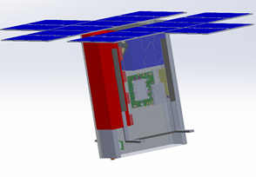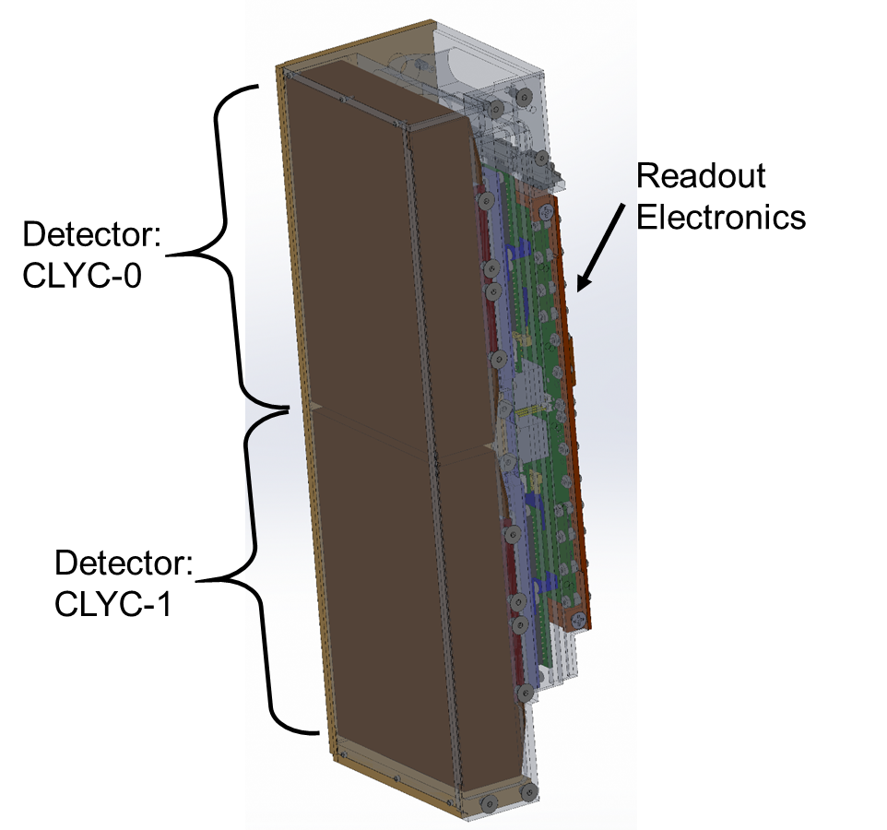

Figure 1: Instrument Position in CubeSat

## Port Names/Locations

There are three micro-D connectors on the Mini-NS. Take note of the orientation of the instrument in the spacecraft from Figure 1, as the port for detector CLYC-0 is on the opposite side to the port for CLYC-1. The power port is a socket micro-D connector.

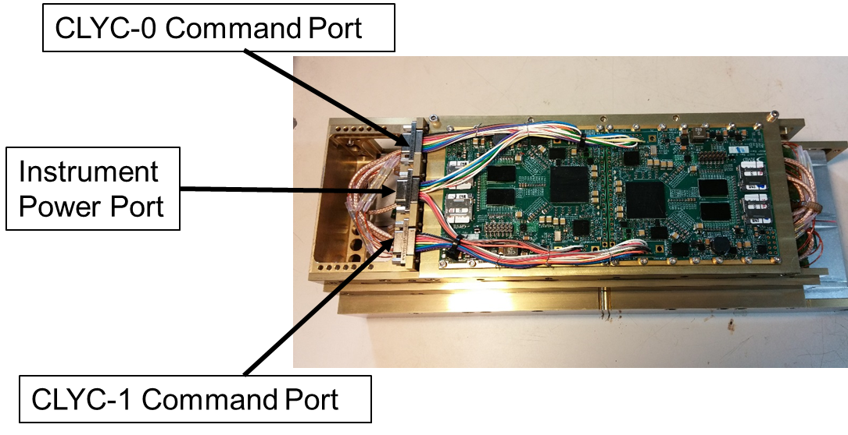

Figure 2: Detector Connector Ports

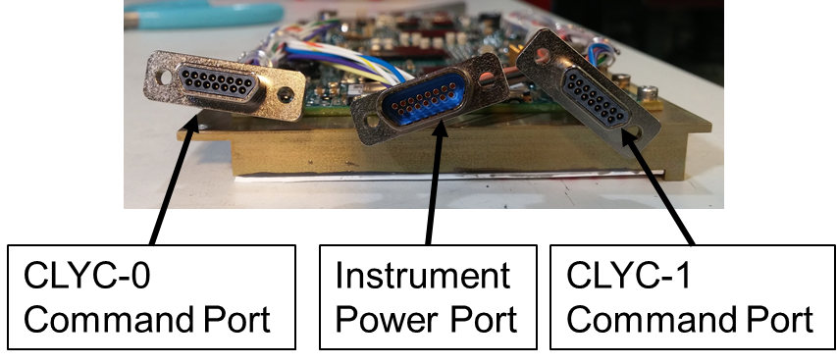

Figure 3: Head on View of Detector Connector Ports

## Power Dissapation

The data in Table 1 are the power consumption of the MiniNS during different operational states. The DAQ and WF commands will energize the active readout components to prepare the system to collect data. These numbers reflect the total power consumption for the Mini-NS, a sum of both CLYC-0 and CLYC-1.

Table 1: Power Consumption.

|  |  |  |  |  |  |  |
| --- | --- | --- | --- | --- | --- | --- |
| **Power Configuration** | **Min. Power**  **(W)** | **Power  (W)** | **Max. Power**  **(W)** | **Processor** | **Active Readout and HV** | **In-Rush Current (A)** |
| **OFF** |  | 0.0 |  |  |  |  |
| **STDBY** | 3.4 | 3.6 | 4.0 | ✓ |  |  |
| **DAQ** | 8.0 | 9.6 | 10.5 | ✓ | ✓ |  |

The input voltage is regulated +12 V ± 20%.

## RS-422 Serial port Parameters

BAUD Rate: 921600

Data: 8-bit

Parity: None

Stop 1-bit

Flow Control: None

# Mechancial Interface

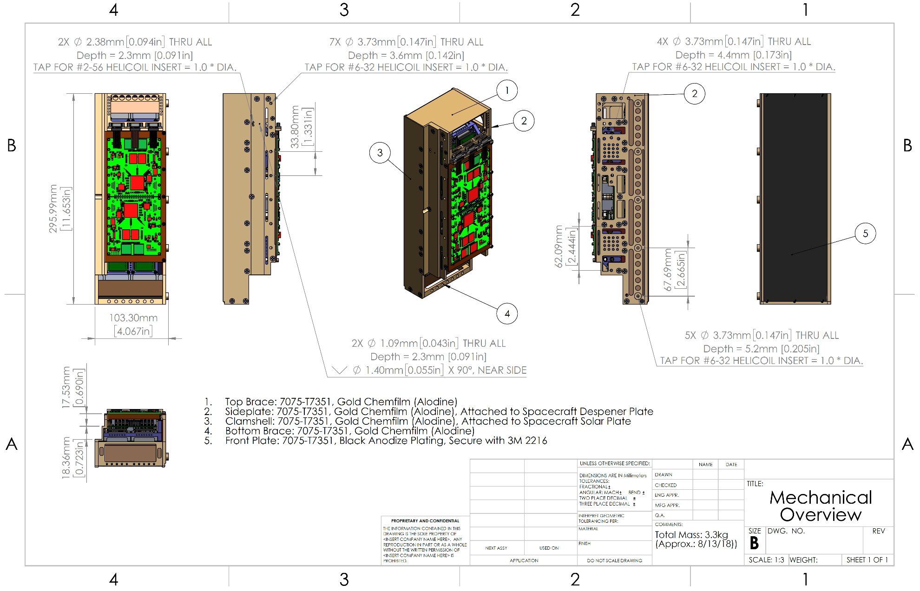

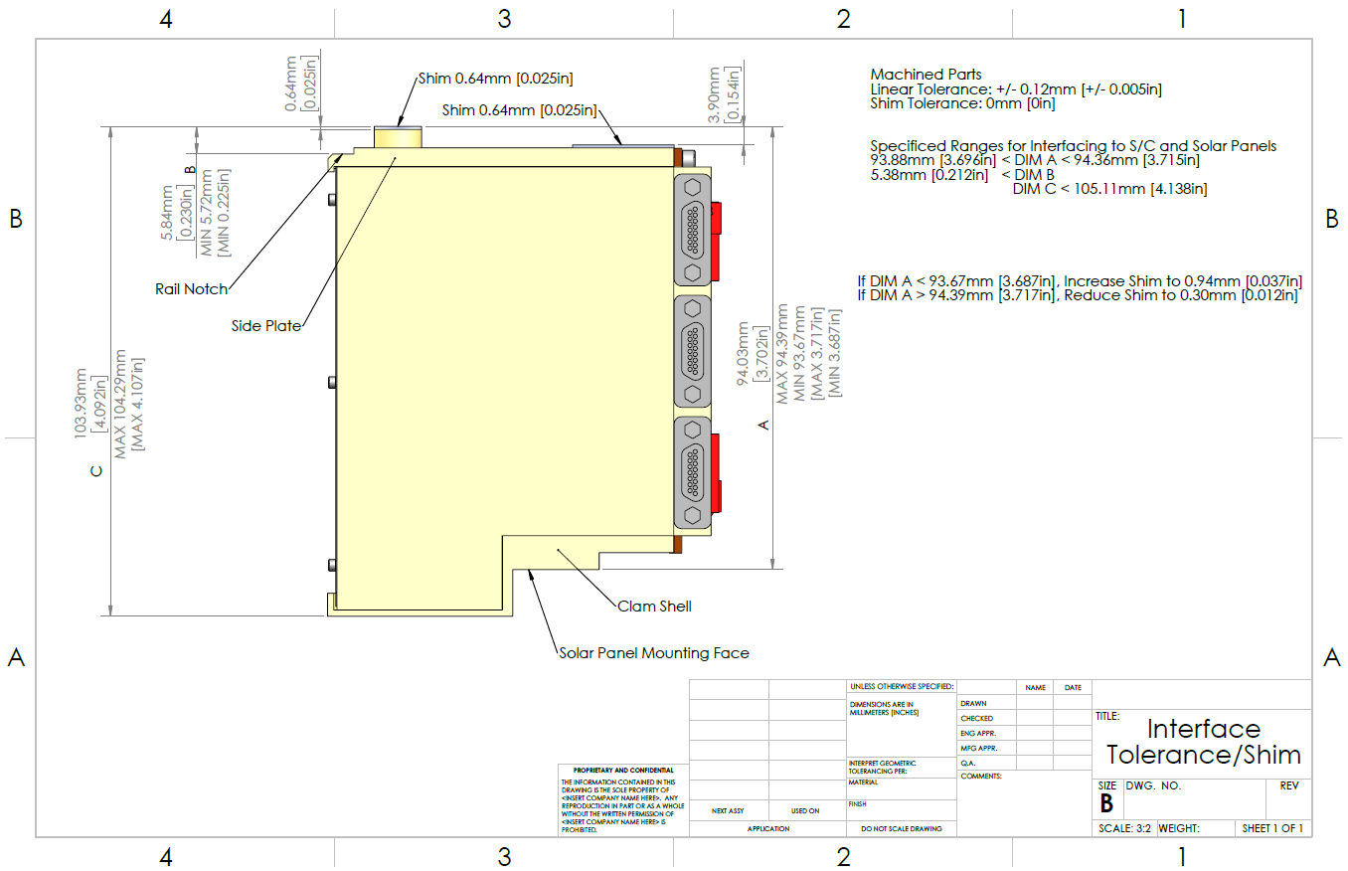

# Thermal Interface

The analog board and detector modules are thermally isolated from the rest of the instrument and spacecraft. The following drawing provides the data for assessing the thermal connection from the thermally isolated components to the spacecraft chassis. The digital board has a strong thermal connection to the spacecraft side panels.

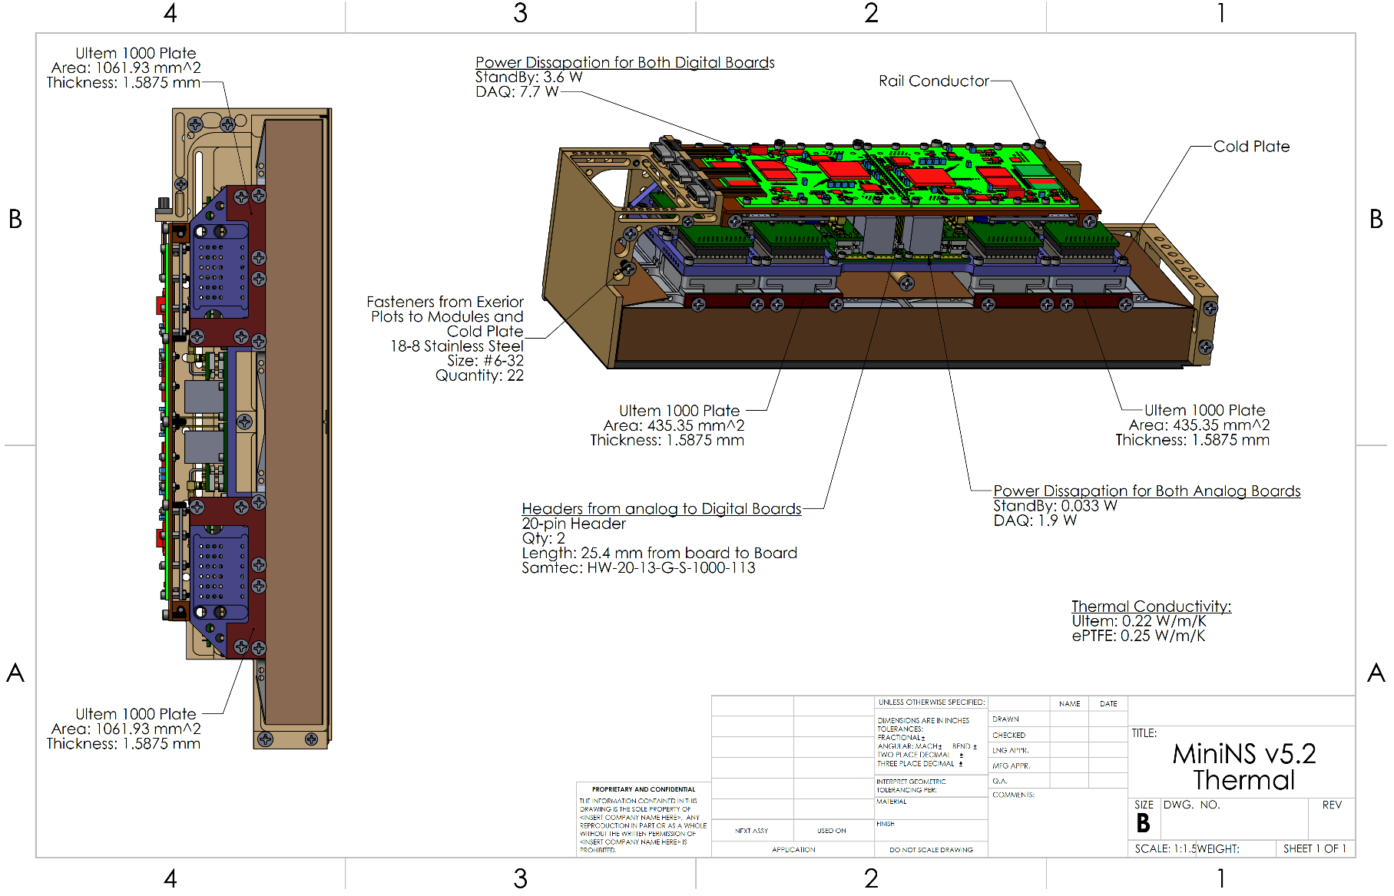

# electrical connector PINOUTs

## Overview

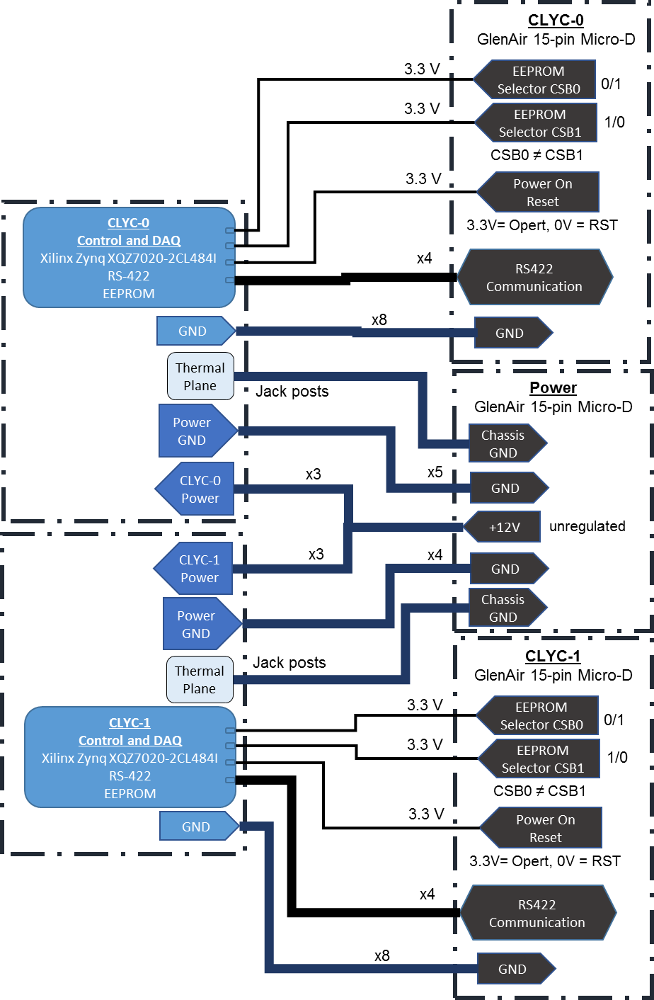

Figure 4: Electrical Ports Overview- CSB0, CSB1, POR are active-low signals.

## Power Port (15-pin Power: GlenAir MWDM2L-15S-4J5-18P)

|  |  |  |  |  |  |  |  |  |  |
| --- | --- | --- | --- | --- | --- | --- | --- | --- | --- |
| MWDM | 2 | L | 15 | S | 4 | J | 5 | 18 | P |
| Micro-D | Nickel | LCP  30% Glass-Filled Liquid Crystal Polymer | Contact Number | Socket | #24 AWG | M22759/33 600VRMS Modified Cross-Linked Tefzel | Color-Coded Stripes per MIL-STD-681 | 18” | Jackpost |

Mate: MWDM2L-15P-4J5-18M (Socket with Hex Head Jackscrew)

Table 2: Pin out for Power Connector

|  |  |  |  |  |
| --- | --- | --- | --- | --- |
| Purpose | Pin | K:\Research Files\NASA\C16-018 LunaH-Map\CAD Models\02_23_2017 Flight Unit v5.1\Digital Board\mwdm2l-15p-6e5-18.PNG | Pin | Purpose |
| |  |  | | --- | --- | | CLYC-1 GND | 15 | | CLYC-1 GND | 14 | | CLYC-1 GND | 13 | | CLYC-1 GND | 12 | | CLYC-0 GND | 11 | | CLYC-0 GND | 10 | | CLYC-0 GND | 9 | | | 8 | CLYC-1 +12V |
| 7 | CLYC-1 +12V |
| 6 | CLYC-1 +12V |
| 5 | CLYC-1 GND |
| 4 | CLYC-0 GND |
| 3 | CLYC-0 +12V |
| 2 | CLYC-0 +12V |
| 1 | CLYC-0 +12V |
|  | |

Jackscrews are connected to Chassis Ground.

The jackpost is threaded for 2-56.

## Command port (15-pin Power: GlenAir MWDM2L-15P-4J5-18P)

|  |  |  |  |  |  |  |  |  |  |
| --- | --- | --- | --- | --- | --- | --- | --- | --- | --- |
| MWDM | 2 | L | 15 | P | 4 | J | 5 | 18 | P |
| Micro-D | Nickel | LCP  30% Glass-Filled Liquid Crystal Polymer | Contact Number | Pin | #24 AWG | M22759/33 600VRMS Modified Cross-Linked Tefzel | Color-Coded Stripes per MIL-STD-681 | 18” | Jackpost |

Mate: MWDM2L-15S-4J5-18M (Socket with Hex Head Jackscrew)

Table 3: Pin out for Data Connectors

|  |  |  |  |  |
| --- | --- | --- | --- | --- |
| Purpose | Pin | K:\Research Files\NASA\C16-018 LunaH-Map\CAD Models\02_23_2017 Flight Unit v5.1\Digital Board\mwdm2l-15p-6e5-18.PNG | Pin | Purpose |
| |  |  | | --- | --- | | RS422 RX\_P | 9 | | GND | 10 | | GND | 11 | | RS422 TX\_N | 12 | | GND | 13 | | GND | 14 | | GND | 15 | | | 1 | GND |
| 2 | GND |
| 3 | RS422 RX\_N |
| 4 | GND |
| 5 | Power On Reset (POR) |
| 6 | RS422 TX\_P |
| 7 | EEPROM 2 (CS\_2) |
| 8 | EEPROM 1 (CS\_1) |
|  | |

Jackscrews are connected to Chassis GND.

The jackpost is threaded for 2-56.

The pin i/o locations are identical for CLYC-0 and CLYC-1.

# Grounding

There are two grounds associated with interfacing with the instrument. These include a chassis ground and ground (GND). The chassis ground is the native one associated with the instrument housing, but it should be noted that the chassis ground is used to dissipate heat from the electronics to the spacecraft. There is an unspecified capacitive or inductive impedance to chassis ground from the instrument electronics (Z). There is a GND connection from power (+12V regulated supply voltage) to the instrument, which is the power return ground, and a GND from the CD&H to the instrument. The instrument handles grounding internally after a regulated +5V is produced.

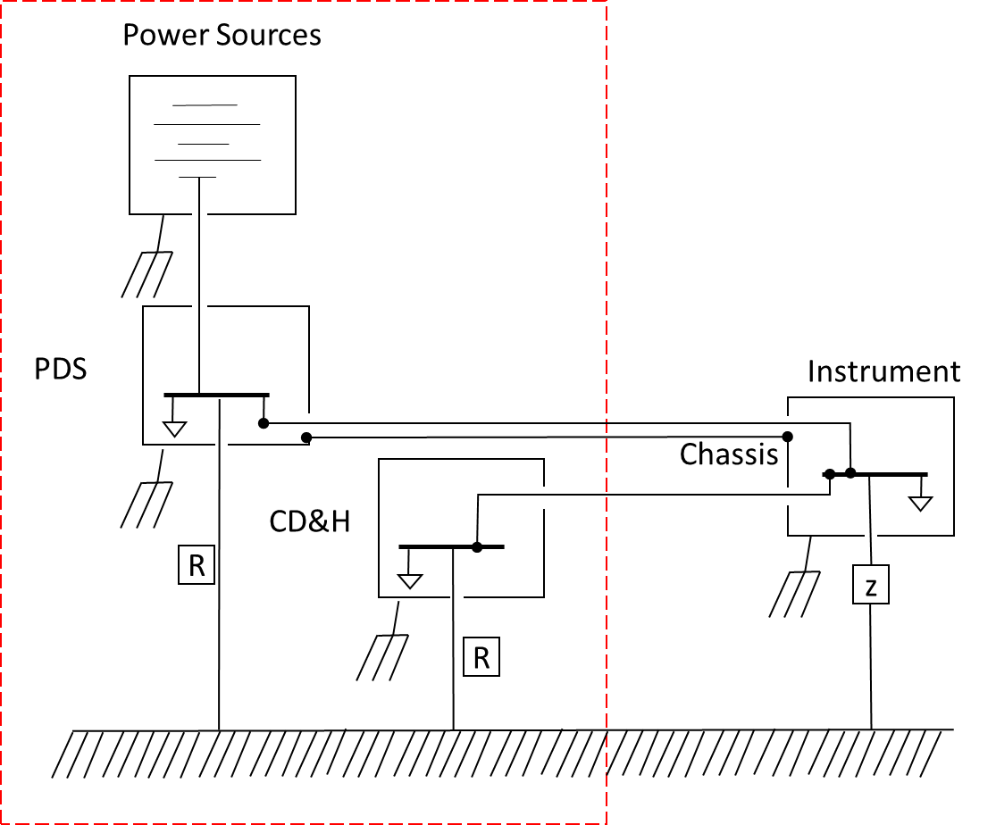

Figure 5: Detector Grounding Diagram

# Operation Overview

## Operation Overview

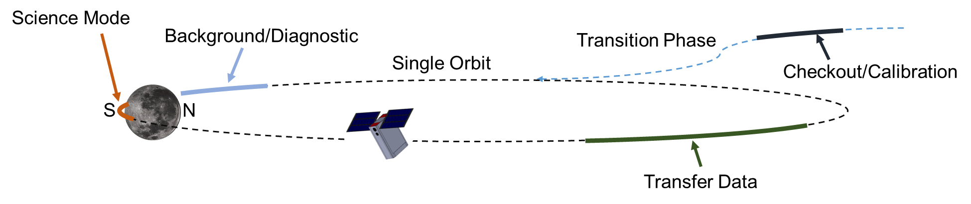

Figure 6: Operation Overview

The operation will consist of five different operations

1. Checkout/Calibration
2. Background/Diagnostic
3. Data Acquisition State
4. Transfer State
5. Standby Mode

### Checkout/Calibration

The instrument is turned on and operated during orbit transition. Data will be collected to assess the health of the instrument. Data will be captured from each detector module (CLYC/PMT) and transferred back to Earth. The data is processed on Earth to assess the health of the instrument and to upload any calibration corrections. The calibration points include gain adjustment for the PMTs, energy calibration, trigger thresholds, and cut values for reducing data.

### Background/Diagnostics/Temp

The instrument is operated near the moon before the science mode operation. The data collected in this region will serve for diagnostics purposes.

### Data acquisition state

The data acquisition state is where science data is collected. The Mini-NS will collect data around the south pole of the moon. Counts are automatically transferred to the UART buffer and all data products are stored to SD Flash memory.

### Transfer state

The transfer state allows the spacecraft to extract data from the SD Flash memory on the instrument for downlinking to Earth. These data are written into one or many CCSDS packets and sent to the bus. This state will be held until the file to be transferred has been completely transferred or a BREAK command is received. Any file one the spacecraft SD card may be transferred. This state may be broken out of to return to standby mode.

### Standby Mode

The instrument will be in a low-power state (ADC off, etc.) where it will not respond to commands and will need to be energized to be interactive. This mode may be utilized when in portions of the orbit where the instrument serves no particular purpose.

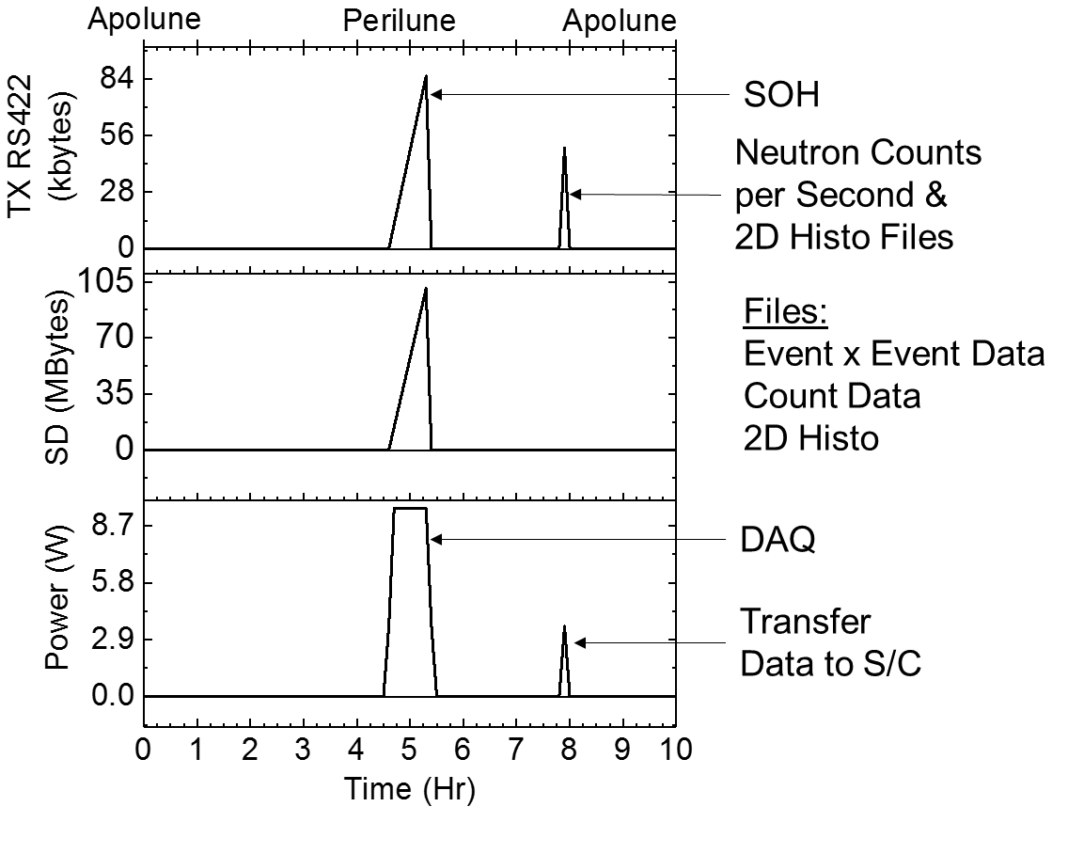

Figure 7: Example diagram of resource consumption for one science orbit. The graph indicates the transmission of the neutron count data and 2D histogram data. The plot assumes a 10 hour orbit with a 30 min data acquistion time.

## Software and Configuration

The software environment operates on a Cortex Arm-9 Processor. The Cortex processor is packaged with a Xilinx Artix-7 FGPA interfaced using an AXI bus. The system family used for LunaH is a XC7Z020 Zynq. The code is developed using Xilinx’s Software Development Kit Version 2017.4. The system boots from either of the EEPROM flash devices that contains the software for the processor and bitstream for the FPGA. The instrument uses a polling method for control.

Power On or Reset initiates a series of operations which boot the system from the selected EEPROM and execute the processor program. The initial steps in the program conduct a self-check, clear the RS422 line, and set default parameters. The code is then set in a polling state, referred to as standby mode. The boxes highlighted in blue in Figure 8 are interfacing blocks with the spacecraft, called Commanded Input. The boxes highlighted in green in Figure 8 indicate that the system changes state as a result of commanded input from the spacecraft. Data acquisition is a new state accessed by commanded input. Statement-Of-Health (SOH) is reported once per second and is indicated by boxes which have dashed outlines.

While in standby mode, the system reads the UART read buffer char by char and then stops at a new-line (“\n”) return character. Top level commands are broken into four categories (data acquisition selection, system control, data file handling, and setting instrument parameters). Self-terminating processes are ones that will return the system back to Standby Mode without further input, as shown by Figure 9. Functions such as enabling active components or setting the trigger threshold fall under this category.

Data acquisition enters a new polling loop, see Figure 10. In this mode, data is acquired from the FPGA and processed. The full context of the data is written to the SD memory across multiple file types, described in 9.MINI-NS OUTPUT. The RS422 buffer is continuously polled for user input, meanwhile the SOH data packets are written to the RS422 at a rate of 1Hz. If the data acquisition stop command is sent (“END\_*RealTime*\n”) by the spacecraft, the system will close out any open data files, execute end of run operations and return to the primary polling loop in standby mode.

Default parameters for the Mini-NS system are loaded during the startup steps after a Power On or Power On Reset. These parameters are listed in Table 4 and constitute all of the variables which affect how the system collects data during data acquisition. The defaults are the initial defaults hard coded into the software. The most recent values are stored in a configuration file, called “ConfigFile.cnf”, which is then used to update the variables.

To inform the spacecraft that the Mini-NS is powered on and active, Statement of Health (SOH) data is generated once per second, wrapped in a CCSDS packet and sent to the RS422. SOH data packets will contain temperature information, the most current neutron count calculation, and the local Mini-NS time, see Table 14 RMD Statement of Health Format. This information will be stored in the data bytes of the CCSDS packet. The packet also contains a Reset Byte field, found in the header, which needs to be checked in case the Mini-NS has encountered a fault and needs to be reset.

Table 4: Default Parameter Set

|  |  |  |
| --- | --- | --- |
| Parameter | Value | Unit |
| Trigger Threshold | 8500 |  |
| Baseline Integral | -52 | ns |
| Short Integral | 88 | ns |
| Long Integral | 472 | ns |
| Full Integral | 6000 | ns |
| Energy Cut Low | 2.5 | MeV |
| Energy Cut High | 3.6 | MeV |
| PSD Cut Low | 0.21 |  |
| PSD Cut High | 0.35 |  |
| Wide Energy Cut Low | 2.0 | MeV |
| Wide Energy Cut High | 4.1 | MeV |
| Wide PSD Cut Low | 0.15 |  |
| Wide PSD Cut High | 0.40 |  |
| Energy Calibration Slope | 0.05 | MeV |
| Energy Calibration Intercept | 50 | MeV |
| High Voltage of PMT 0 | 190 |  |
| High Voltage of PMT 1 | 190 |  |
| High Voltage of PMT 2 | 190 |  |
| High Voltage of PMT 3 | 190 |  |

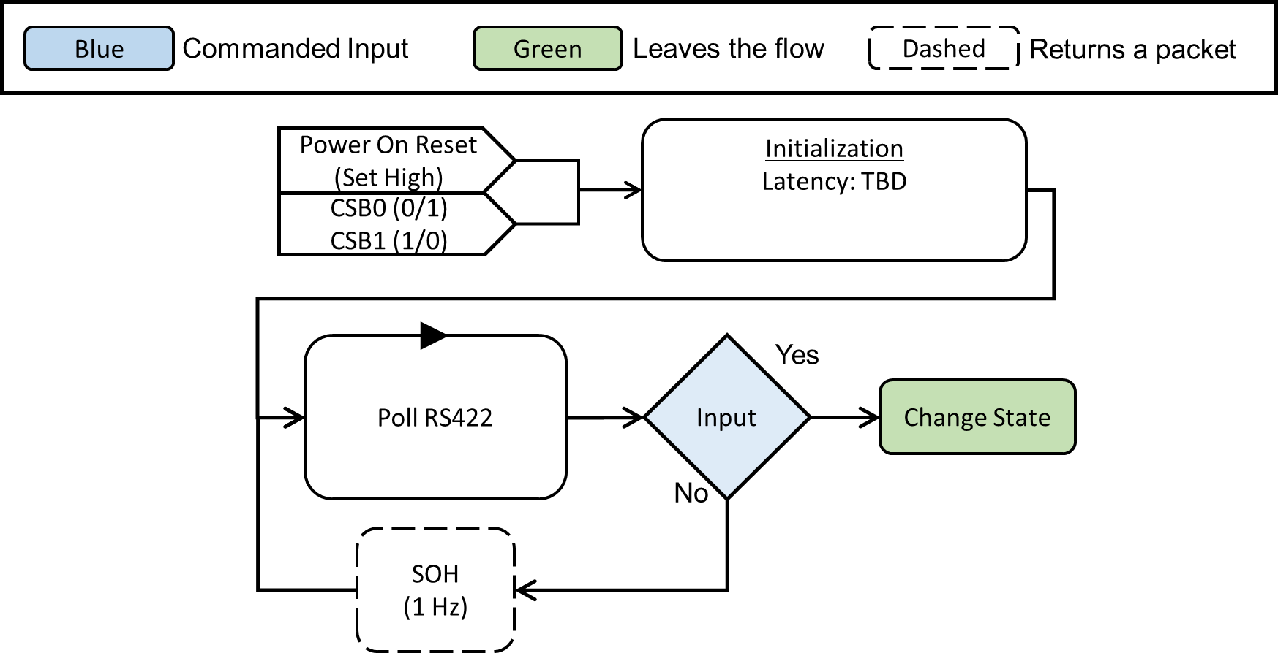

Figure 8: Top-Level Diagram of Software Operation

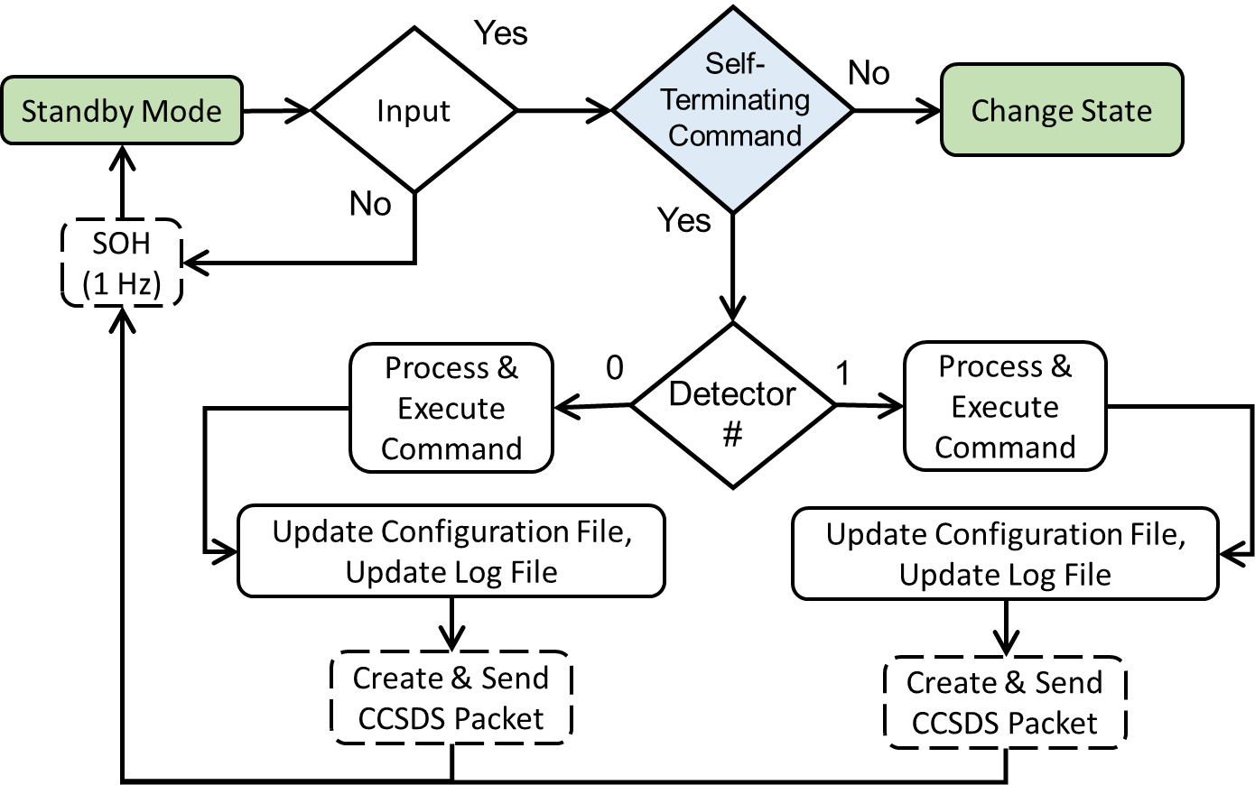

Figure 9:Self-Terminating Command Flow

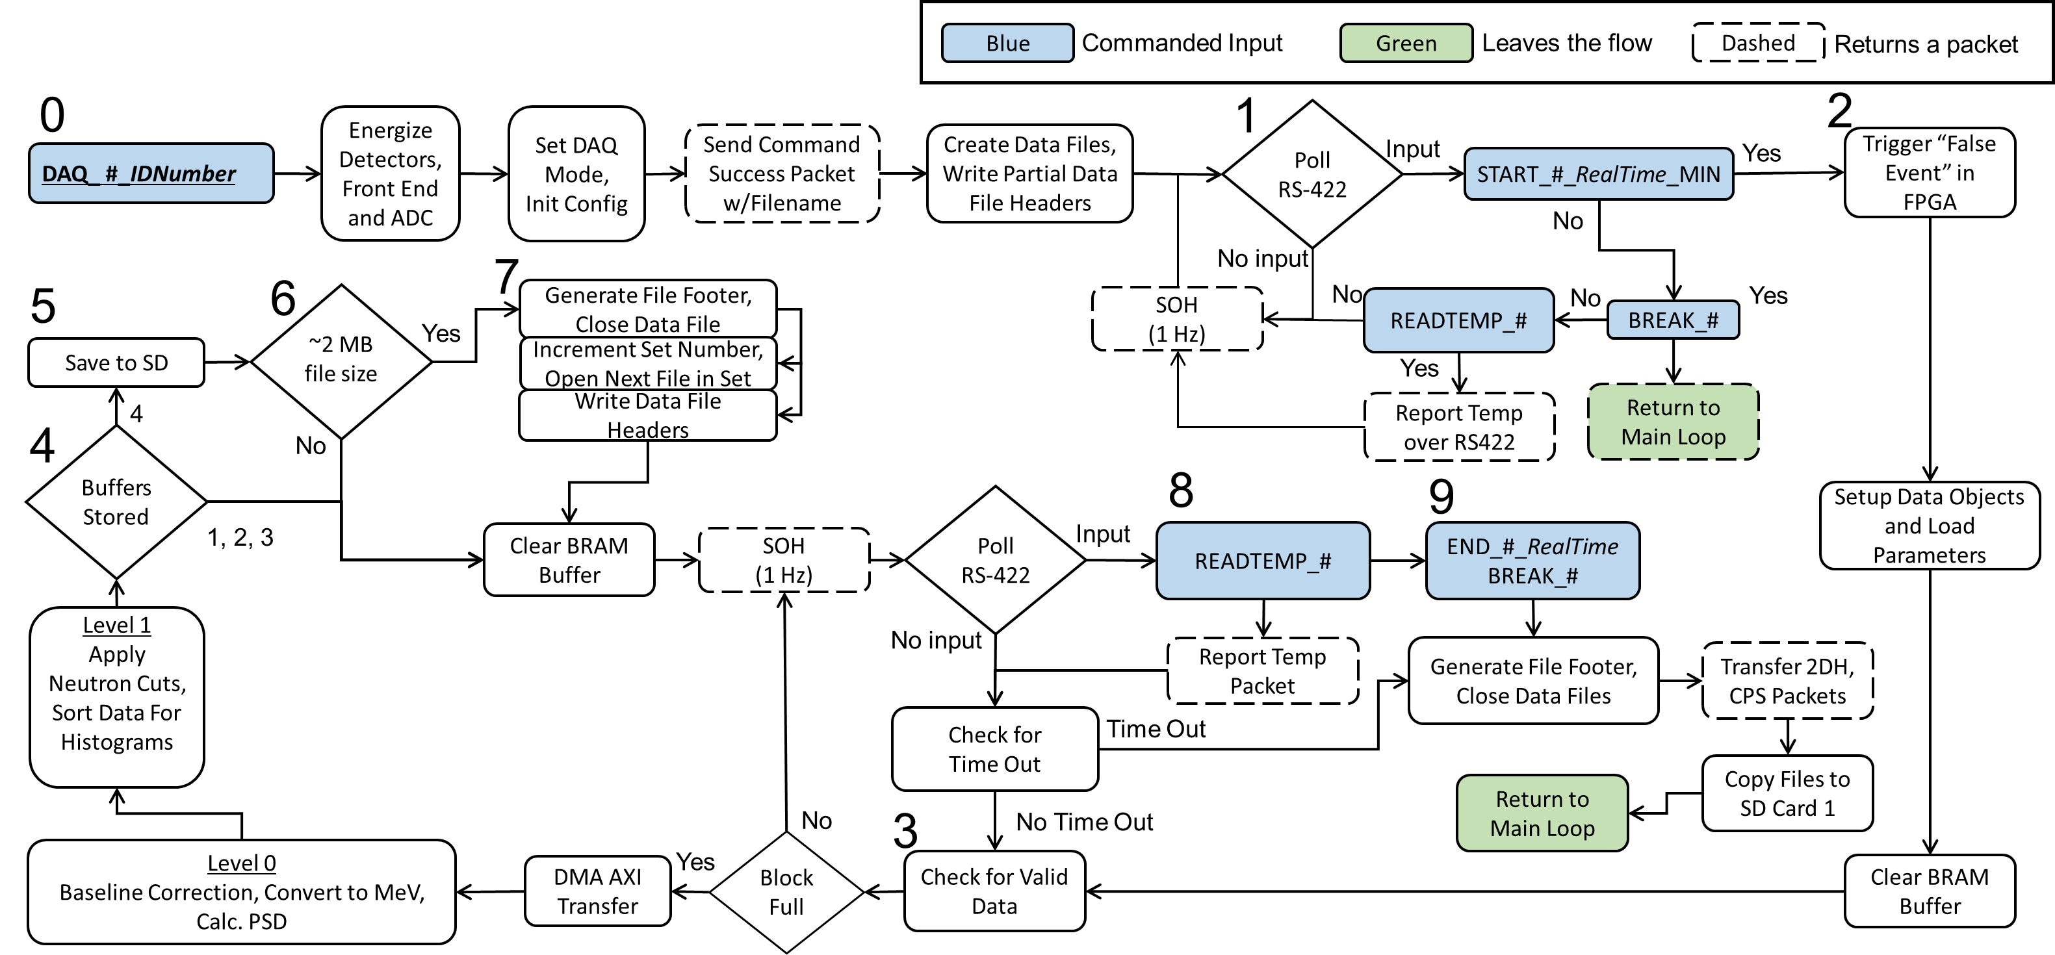

Figure 10 Data Acquisition Loop

# signal processing

## Digital Signal

There are two signals from each detector module. The primary signal is a summed signal for all of the modules, which is routed through a buffer amplifier and a fast analog to digital converter (ADC). The ADC is operated at 250 MSPS, and this is the signal that will be processed for determining if the event was from a neutron. The other signal is a logic pulse generated from an analog circuit that is triggered when there is a large signal from any of the modules.

## Trigger

The digital signal is routed to the FPGA, and the first step is to generate a trigger to gate the event. The trigger is based on signal differentiation, and the threshold has a baseline of 8192. The electronics are setup to account for positive going pulses, and a threshold greater than 8192 is expected. When the trigger signal is above the threshold, then the event gate is generated.

## Integration

The primary (summed) signal is delayed with respect to the trigger by 200 ns, and four integrals (baseline, short, long, full) are produced. A time of 0 ns along the signal is the point where the signal crossed the threshold. The integration times are with respect to this time zero point. The integrals, event number, total number of events, and time from an FPGA counter are placed in a circular buffer that will hold 510 events.

## Level 0 processing

After transferring the buffer to the Zynq processor, the data is baseline corrected. The baseline correction uses the baseline integral to get an average of the baseline to be subtracted from the other integrals. The pulse shape discrimination ratio (PSD) is given by $PSD=$ $\frac{SI}{\left(LI-SI\right)}$ ( 1.

$PSD= \frac{SI}{\left(LI-SI\right)}$ ( 1 )

When the energy of the pulse and the PSD ratio have been calculated, a calibration on the energy may be performed. The equation for this is a simple linear relation, shown in $E=y0+s×FI$ ( 2.

$E=y0+s×FI$ ( 2 )

PSD = Pulse Shape Discrimination

E = Energy

y0 = Energy calibration Intercept

s = Energy calibration slope

SI = Baseline Corrected Short Integral

LI = Baseline Corrected Long Integral

FI = Baseline Corrected Full Integral

## Level 1 Processing

A series of neutron cuts are applied to each event to determine if the event resides within the cut window region. The window regions are user defined and may be changed. An example of the cuts on the neutron peak is shown in Figure 10 - Figure 12. The initial cut may be be narrow (the cut window range is defined using parameters in the configuration file), and additonal neutron count totals are determined with only an energy cut window. An additional cut on the neutrons with wider (larger region of interest) paramters is also made. The user may define this second, wider window over any region of interest. Another count total will be made where events above 10 MeV will be aggregated. For overall data collection, the neutron counts will be aggregated, and the data will be sorted for filling the 2D historgams.



Figure 11: PSD distribution with a ‘narrow’ cut region to give neutrons w/ PSD.



Figure 12: The cut region defined only by the energy values to give neutrons w/o PSD

****

Figure 13: A second cut window showing a wider region of interest to give neutrons with a wide cut.

# Software Commands

Commands are sent to the instrument as ASCII statements.

Parameters may follow the command and can be either integers, floats, or strings, as described below. All parameters are required and are documented by this section which includes the expected data type necessary. Any input given to the command will be parsed as the data type given.

**The parsing relies on the “\_” (underscore) character.**

The number which follows the command is the **Detector ID (0 or 1) indicated as “#” (pound)** in the command list below.

**Command must be terminated with a newline “\n” character.**

On the completion of a command, the return value, see Table 12 RMD Command Success Format/Table 13, will be written to the RS422 wrapped in a CCSDS packet; these return values are listed below each command. The success or failure of a command is indicated via the APID bytes (ie. the type of packet returned), see Table 7. All commanded functions return a CCSDS packet upon completion, but some output a packet other than SUCCESS if successful (eg. Get Status returns a SOH packet instead of a SUCCESS packet).

TOP LEVEL

Capture Data (Loop)

Syntax: MNS\_DAQ\_#\_*IDNumber*

* *IDNumber* = (Integer) identifier number

Description: Initialize the system and prepare to take science data. The active components are energized, data objects are created in the code, and parameters for operation are loaded (e.g. HV is set). Data files are generated and opened. The system will be in a new polling loop. Return packet is sent at the end of a run.

Latency: TBD

Sub Commands: START\_#\_*RealTime*, BREAK \_#, READTEMP\_#

Return Data Packet Type: Command Success (0x00) / Command Failure (0x11)

Capture AA Waveforms (Loop)

Syntax: MNS\_WF\_#\_*WFType\_NumWaves*

* *WFType* = (Integer) the type of waveform to capture (0=AA, ~~3=TRG~~)
* *NumWaves* = (Integer) the number of waveforms to capture

Description: Initialize the system and prepare to take diagnostic data. The active components are energized, data objects are created in the code, and parameters for operation are loaded (e.g. HV is set). Data files are generated and opened. The system will be in a new polling loop. A bypass will be set within the FPGA to only stream out the data captured from the ADC before integration.

Latency: TBD

Sub Commands: BREAK \_#

Return Data Packet Type: Command Success (0x00) / Command Failure (0x11)

**System Controls** (Self Terminating)

Read Temperature

Syntax: MNS\_READTEMP\_#

Description: Read the current temperature of all three temperature sensors. There are temperature sensors on the analog board, the digital board, and one attached to a module

Latency: TBD

Return Data Packet Type: Temperature (0x44) / Command Failure (0x11)

Get Status

Syntax: MNS\_GETSTAT\_#

Description: Request the SOH information of the instrument.

Latency: TBD

Return Data Packet Type: Statement of Health (0x22) / Command Failure (0x11)

Disable Data Acquisition Components

Syntax: MNS\_DISABLE\_ACT\_#

Description: Disable all the active components.

Latency: TBD

Return Data Packet Type: Command Success (0x00) / Command Failure (0x11)

**Enable Data Acquisition Components**

Syntax: MNS\_ENABLE\_ACT\_#

Description: Enable all the active components.

Latency: TBD

Return Data Packet Type: Command Success (0x00) / Command Failure (0x11)

**Break**

Syntax: MNS\_BREAK\_#

Description: Break out of any looping process and return to the main polling loop.

Latency: TBD

Return Data Packet Type: Command Success (0x00) / Command Failure (0x11)

Data File Handling (Self Terminating)

Transfer Data File

Syntax: MNS\_TX\_#\_*FileType\_IDNumber\_RunNumber\_SetNumLow\_SetNumHigh*

* *FileType =* (Int) value 0 – 6 indicating the type of file to transfer
* *IDNumber =* (Int) DAQ Identifier number
* *RunNumber =* (Int) DAQ Run number
* *SetNumLow =* (Int) First set number to be transferred
* *SetNumHigh =* (Int) Last set number to be transferred

Description: Transfer a data or log file stored on the instrument’s SD card. To transfer a data product file off of the Mini-NS SD card, the user must specify the data product file type along with its run information. The data product file types available for transfer are:

* 5 = Counts per second
* 6 = Waveform
* 7 = Event-by-event
* 8 = 2D histogram data from PMT 1
* 11 = 2D histogram data from PMT 2
* 12 = 2D histogram data from PMT 3
* 13 = 2D histogram data from PMT 4

The ID number and run number for the

The first CCSDS packet returned will have Group Flags set to 0x01 (first packet) or 0x11 if there is only one packet to be sent. Intermediate packets will have their Group Flags set to 0x00 and the final packet will have Group Flags of 0x10 (last packet). If no packet with Group Flags of 0x10 are received, then the file was not completely transferred; there was no error in the transfer. If the function is unsuccessful at any point, then a Command Failure is issued instead and the transfer is exited.

Latency: TBD

Sub Commands: BREAK\_#

Return Data Packet Type:

* MNS\_CPS (0x55)
* MNS\_WAV (0x66)
* MNS\_EVTS (0x77)
* MNS\_2DH (0x88)

Delete Data File

Syntax: MNS\_DEL\_#\_*Filename*

* *Filename =* (String) *Orbitnumber*\_*Runnumber.Type*, LogFile.txt, ConfigFile.cnf

Description: Checks to see if the specified file exists on the instrument’s SD card. If it does, the file is deleted, otherwise the functions fails and returns to the main menu.

Latency: TBD

Return Data Packet Type: Command Success (0x00) / Command Failure (0x11)

List Data Files

Syntax: MNS\_LS\_FILES\_#

Description: Transfer the list of all files stored on the instrument’s SD card.

Latency: TBD

Return Data Packet Type: LS File Return (0x33) / Command Failure (0x11)

Transfer Log File

Syntax: MNS\_TXLOG\_#

Description: Transfer the log file as stored on the instrument’s SD card.

Latency: TBD

Return Data Packet Type: Log File (0x99) / Command Failure (0x11)

Transfer Configuration File

Syntax: MNS\_CONF\_#

Description: Transfer the configuration file as stored on the instrument’s SD card.

Latency: TBD

Return Data Packet Type: Configuration File (0xAA) / Command Failure (0x11)

Setting Instrument Parameters (Self Terminating)

Set Event Trigger Threshold

Syntax: MNS\_TRG\_#\_*Threshold*

* *Threshold* = (Integer) A value between 0 – 73728

Description: Change the instrument’s trigger threshold. This value is recorded as the new default value for the system.

Configuration Parameter: Trigger Threshold

Latency: TBD

Return Data Packet Type: Command Success (0x00) / Command Failure (0x11)

Set Energy Calibration Parameters

Syntax: MNS\_ECAL\_#\_*Slope\_Intercept*

*Slope =* (Float) value for the slope

*Intercept* = (Float) value for the intercept

Description: These values modify the energy calculation based on the formula

Energy = *Slope*\*FI + *Intercept*.

FI = the baseline corrected full integral.

Configuration Parameter:

*Slope* = Energy Calibration Slope

*Intercept* = Energy Calibration Intercept

Latency: TBD

Return Data Packet Type: Command Success (0x00) / Command Failure (0x11)

Set Neutron Cut Gates

Syntax: MNS\_NGATES\_#\_*ModuleNum\_EllipseNum*\_Scale*E\_ScaleP\_OffsetE\_OffsetP*

* *ModuleNum* = (Int) detector module to modify the cuts for, values: 1-4
* *EllipseNum* = (Int) select which ellipse to modify, values: 1, 2
* *ScaleE* = (Float) scale factor for the X-axis (energy) of the ellipse, values: 0 – 25.5
* *ScaleP* = (Float) scale factor for the Y-axis (PSD) of the ellipse, values: 0 – 25.5
* *OffsetE* = (Float) move the center of the ellipse in the X-direction, values: 0-10 MeV
* *OffsetP =* (Float) move the center of the ellipse in the Y-direction, values: 0-10 MeV

Description: The Mini-NS uses ellipses to define cuts on the neutron peak while collecting data. These ellipses can be modified by scale factors (ScaleE/P) and/or shifting their center points (OffsetE/P). The cuts can be made on a module-by-module basis and each module has up to 2 ellipses to modify. No checks on the values submitted are performed at this time. The default cuts are implemented as: scaleE/P = 1.0 (no scale factor) and offsetE/P = 0.0 (no offset).

Configuration Parameter:

*ScaleE =* Ellipse scale factor along Energy axis

*ScaleP =* Ellipse scale factor along PSD Ratio axis

*OffsetE =* Ellipse center point offset Energy axis

*OffsetP =* Ellipse center point offset PSD ratio axis

Latency: TBD

Return Data Packet Type: Command Success (0x00) / Command Failure (0x11)

Set High Voltage

Syntax: MNS\_HV\_#\_*PMTID\_Tap*

* *PMTID* = (Integer) PMT ID, 1 – 4, 5 to choose all tubes
* *Tap=*  (Integer) high voltage potentiometer tap, 0 – 255

Description: Set the bias voltage on any PMT in the array. The PMTs may be set individually or as a group.

The conversion from the potentiometer tap value to the high voltage is

$HV= -172.616-3.03125∙Tap+0.0025∙{Tap}^{2}-1.27748×{10}^{-5}∙{Tap}^{3}$

Configuration Parameter:

*PMTID = 0: Tap =* High Voltage of PMT 0

*PMTID = 1: Tap =* High Voltage of PMT 1

*PMTID = 2: Tap =* High Voltage of PMT 2

*PMTID = 3: Tap =* High Voltage of PMT 3

Latency: TBD

Return Data Packet Type: Command Success (0x00) / Command Failure (0x11)

Set Integration Times

Syntax: MNS\_INT\_#\_*Baseline\_Short\_Long\_Full*

Times are in nanoseconds

* *Baseline =* (Signed Integer) baseline integration stop time: -190 ns – -52 ns
* *Short =* (Signed Integer) short integration stop time: 0 ns – 6000 ns AND < *Long*
* *Long =* (Signed Integer) long integration stop time: 0 ns – 6000 ns AND < *Full*
* *Full =* (Signed Integer) full integration stop time: 0 ns – 6000 ns

Description: Set the integration times for event-by-event data. The time that the pulse crosses threshold is defined as 0 ns with respect to these integration times. After the system is triggered, it will delay the pulse (waveform) by 200 ns, and all integration times start at -200 ns. The integration is stopped at a sample point in the waveform which is multiple of 4 ns. This stop sample point is an integer value.

$$Number of Samples=int\left(\frac{Stop Time+200ns}{4ns}\right)+1$$

*Stop Time =*  The time of any of the stop times inputs from above.

The int() is the integer function, which rounds down the number to the nearest integer.

Configuration Parameter:

*Baseline =* Baseline Integral

*Short =* Short Integral

*Long =* Long Integral

*Full =* Full Integral

Latency: TBD

Return Data Packet Type: Command Success (0x00) / Command Failure (0x11)

SUB LEVEL

These are sub-commands to the top level commands. These commands are for starting or stopping data acquisition. Outside of that context, these commands have no function and will return a command failure.

Start Data Acquisition (Loop)

Access Command: MNS\_DAQ or MNS\_WF

Syntax: MNS\_START\_#\_*RealTime\_MIN*

* *RealTime =* (Unsigned Integer)Real time from the spacecraft
* *MIN =* (Signed Integer)number of minutesto acquire data. ‘0’ indicates no stop time. A time must be specified otherwise this command will be rejected.

Description: The START command is only accepted by the DAQ and WF top-level commands. The START command places the system from the DAQ pre-loop into DAQ state, capturing data while polling the bus at regular intervals. The system will discard non-BREAK commands while looping. The data acquisition will stop after *MIN* number of minutes, if not interrupted.

Latency: TBD

Sub Commands: MNS\_END\_#\_*RealTime*, MNS\_Break\_#, MNS\_READTEMP\_#

Return Data Packet Type: None

End Data Acquisition

Access Command: MNS\_DAQ or MNS\_WF

Syntax: MNS\_END\_#\_*RealTime*

* *RealTime =* (Unsigned Integer)Real time from the spacecraft

Description: The END command is only accepted by the DAQ and WF top-level commands. END stops the DAQ or WF loop and writes *RealTime* to the event file footer. The detector will not disable the active components (PMT, amplifiers, ADC, etc.) when this command is issued. The data files will be closed.

Latency: TBD

Return Data Packet Type: Command Success (0x00) / Command Failure (0x11)

# MINI-NS OUTPUT

## Mini-NS Output Format

Output is sent from the Mini-NS over the RS-422 UART connection to the spacecraft. The output is packetized in CCSDS packets, as described in Table 5. The format of a CCSDS packet can be broken into a few main components: the Sync Marker, the primary CCSDS header, the secondary CCSDS header, the Mini-NS data bytes, and checksums. Some of these fields are static and will not change over the course of the mission, other fields have a variable value which is listed in Table 6, below.

Table 5 Mini-NS CCSDS Packet

|  |  |  |  |  |  |  |  |  |
| --- | --- | --- | --- | --- | --- | --- | --- | --- |
| **7** | **6** | **5** | **4** | **3** | **2** | **1** | **0** | Byte |
|  | | | | | | | | 0 |
| CCSDS Embedded Sync Marker | | | | | | | | 1 |
| (0x352EF853) | | | | | | | | 2 |
|  | | | | | | | | 3 |
| CCSDS Version Number =0 | | | P.T. = 0 | S.H. = 1 | APID MSB = 010 or 011 | | | 4 |
| APID LSB (Range: 0x00 – 0xFF) | | | | | | | | 5 |
| Group Flags | | Sequence Count MSB | | | | | | 6 |
| Sequence Count LSB | | | | | | | | 7 |
| Packet Length | | | | | | | | 8 |
| (Number of bytes after Primary CCSDS header – 1) | | | | | | | | 9 |
| Reset Request Flag | | | | | | | | 10 |
| Data 0 (Payload Data Bytes) | | | | | | | | 11 |
| (Max N = 2026) | | | | | | | | … |
| End of Data | | | | | | | | N-2 |
| RMD Data Checksum (Simple Checksum) | | | | | | | | N-1 |
| RMD Data Checksum (Fletcher Checksum) | | | | | | | | N |
| Checksum MSB (16-bit sum of all bytes after Sync Marker) | | | | | | | | N+1 |
| Checksum LSB | | | | | | | | N+2 |

**N =** number of bytes of MiniNS Data for the specific packet

Table 6 Mini-NS CCSDS Packet Field Breakdown

| Byte | Description | Group |
| --- | --- | --- |
| 0 | 0x35 | Sync Marker |
| 1 | 0x2E |
| 2 | 0xF8 |
| 3 | 0x53 |
| 4 | 7:5 - CCSDS Version Number = 000  4 - Packet Type (P.T.) = 0  3 - Secondary Header Flag (S.H.) = 1  2:0 – APID MSB = 010 for Mini-NS Detector 0  = 011 for Mini-NS Detector 1  0x0A = Detector 0  0x0B = Detector 1 | Primary CCSDS Header |
| 5 | APID LSB = 0x00 – 0xFF |
| 6 | 7:6 – Group Flags = 00 for intermediate packet  = 01 for first packet  = 10 for last packet  = 11 for unsegmented packet  5:0 – Sequence Count MSB |
| 7 | Sequence Count LSB |
| 8 | Packet Length MSB |
| 9 | Packet Length LSB |
| 10 | Reset Request = 0x00 – No request for reset  = 0x0F – Power off the detector  = 0xFF – Power cycle the detector to STDBY  = 0xF0 – Power cycle the detector to DAQ | Secondary CCSDS Header |
| 11 | Payload Data Byte 0 | Mini-NS Data Bytes |
| … | Payload Data Byte N (max N = 2026) |
| N-1 | Simple Checksum | RMD Data Checksums |
| N | Fletcher Checksum |
| N+1 | Checksum MSB | Checksums |
| N+2 | Checksum LSB |

**N =** number of bytes of MiniNS Data for the specific packet

**APID LSB =** Defines the data type.

This allows the Mini-NS to specify the type of data contained within the packet. Table 7 has the values for all possible APIDs and their data types.

Table 7 APID Table for Mini-NS CCSDS Packets

|  |  |  |
| --- | --- | --- |
| APID LSB | Value | Description |
| Command Success | 0x00 | The input command was successfully executed |
| Command Failure | 0x11 | The input command failed somewhere during execution |
| Statement of Health | 0x22 | Packet contains statement of health information |
| LS Files Return | 0x33 | Packet contains filenames and file sizes for all the file on the Mini-NS SD card |
| Temperature | 0x44 | Packet with the most current temperatures. |
| MNS\_CPS | 0x55 | Neutron Counts per Second Data |
| MNS\_WAV | 0x66 | Waveform Data |
| MNS\_EVTS | 0x77 | Event by Event Data |
| MNS\_2DH | 0x88 | 2D Histogram Data |
| Log File | 0x99 | Log File |
| Configuration File | 0xAA | Configuration File |

**Group ID =** The packet segment location (unsegmented, beginning, middle or end).

If there is just one packet being sent, it is labeled as an unsegmented packet. For other transfers, there will be a first and last packets with multiple intermediate packets in between.

**Sequence Count =** an incrementing number which tells where in the sequence of packets the current packet fits. The sequence counter starts at 0, which corresponds with a Group Flag of 01, and can roll over if the number of packets exceeds 16,383. In that case, the Group Flag will register as 00, indicating an intermediate packet, but the sequence count will return to 0 and begin incrementing again.

**Packet Length =** Number of bytes after packet length minus 1 (includes secondary header, data, and checksum)

**Reset Request =** Reset request flag (See Section 9.2)

**Paylod Data =** Data from the Mini NS for the data type specified from the APID LSB.

The data length is **N** bytes long.

**Simple Checksum =** To calculate the simple checksum, each byte of the packet after the CCSDS Primary Header is added to the value of the checksum, which starts at 0, then the modulus of that value is taken with 255.

**Fletcher Checksum =** The Fletcher checksum is calculated in tandem with the simple checksum. After computing the simple checksum, that value is added to the Fletcher checksum value, which also starts at 0, and the modulus of the combined sum is computed.

**Checksum =** the spacecraft 16-bit checksum to validate the data. This is a sum of all the bytes in the packet which come after the Sync Marker. .

## Reset Request

Each CCSDS data packet contains a reset flag. The detector is specific by byte 4 in the CCSDS header. The specific reset flag is associated with a macro that will operate on the MiniNS. The macro will issue a series of commands to power off the MiniNS detector or to power cycle the detector. If the detector is power cycled, the MiniNS should be operated to recover into a stand by state or into a data acquisition state. Table 8 provides the conditions for setting the reset flags.

Table 8 Reset Request Bytes

|  |  |  |
| --- | --- | --- |
| Reset Request Byte Value | Request | Condition |
| 0x00 | No Request | Mini-NS is in a good state |
| 0x0F | Power Off | Temperature is above specification |
| 0xFF | Power Cycle to STDBY | Instrument is in standby mode. AND  over a 5 sec local time,  1. ~~Neutron counts are not incrementing~~  OR  2. FPGA Time is not increasing |
| 0xF0 | Power Cycle to DAQ | Instrument is in acquistion mode. AND  over a 5 sec local time,  1. Neutron counts are not incrementing  OR  2. FPGA Time is not increasing |

The Mini-NS will actively monitor the temperature of its components including the digital board, the analog board, and at the modules. If the temperature of one of these components overheats, see Table 9, the Mini-NS will set the reset request byte to 0x0F which will cause the spacecraft to completely power down the Mini-NS detector.

Table 9 Mini-NS Temperature Specification

|  |  |
| --- | --- |
| Component | Specification (˚C) |
| Digital Board | -40 – 85 |
| Analog Board | -25 – 50 |
| Modules | -25 – 50 |

## Non-responsive Reset

The recommended default condition for reseting the MiniNS is if there is no data received for at least **5 seconds**.

## Definition of Times

There are three different times which are relevant for proper correlation of data: Local Time, FPGA Time, and Real Time.

**Local Time** refers to the clock running on the processor which is started upon power up.

**FPGA Time** is the time which the FPGA sees and is reported with the data products, as it gives the time the event occurred.

**Real Time** is the time which is issued to the Mini-NS as a parameter to the START commanded input. This time is provided by the spacecraft and will be correlated to the FPGA time to determine where in orbit each event occurred.

Table 10 Time Descriptors

|  |  |  |  |
| --- | --- | --- | --- |
| Name | Provided By | Conversion | Start Point |
| Local Time | Processor | 3 ns per tick | After power up and the boot image is loaded, the clock is an initial command function in the processor code. |
| FPGA Time | FPGA | 262.144 us per tick | After power up and the boot image is loaded, the counter starts. |
| Real Time | Spacecraft | Spacecraft specified | N/A |

## RMD Data Types Formats

This section will discuss the format of the data within the section of the CCSDS packet.

The files on the Mini-NS SD card are created through data collection during science mode or are system files which are maintained internally by the Mini-NS. The Mini-NS produces four types of data products, shown in Table 11.

Table 11 Overview of Mini-NS Science Data Products

|  |  |  |  |  |
| --- | --- | --- | --- | --- |
| Data Product | Transfer | Description | Frequency | Notes |
| MNS\_CPS | To File | Count Data | 1 Hz | Minimum Data Product Returned |
| MNS\_WAV | To File | Waveform Data | Event-by-Event | Diagnostics Only |
| MNS\_EVTS | To File | Processed Event Data | Event-by-Event | Baseline data product returned by request only |
| MNS\_2DH | To File | 2-D Histogram | Execution of END | Record and inform ground about the status of PSD and cuts |

The Count (CPS) data product is the highest priority data product. The data reported in the CPS files will allow the science mission to be completed.

The Waveform (WAV) data product is event-by-event data used for diagnostics and calibration.

Processed Event Data (EVTS) is a complimentary data set to the CPS data which can be used for conducting science, while also giving calibration and diagnostic information.

2-D Histograms (2DH) are saved at the end of each science run and can be downlinked to provide calibration information.

### Command Success

Table 12 RMD Command Success Format

|  |  |  |
| --- | --- | --- |
| Byte | Description | Group |
| 0-8 | Primary CCSDS Header  **Byte 5 = 0x00** | Primary CCSDS Header |
| 9 | **Packet Length = N + 3** |
| 10 | Reset Request Flag | Secondary CCSDS Header |
| 11..N-2 | ASCII Characters (see below) | Data |
| N-1 | Simple Checksum | RMD Data Checksums |
| N | Fletcher Checksum |
| N+1 | CCSDS Checksum MSB | Checksum |
| N+2 | CCSDS Checksum LSB |

The “Data” bytes in the Command Success Packet include the ASCII characters of the submitted command. If the submitted command was DAQ, a newline “\n” character will follow the ASCII characters, then the Packet will include the filename string which will be used for that data acquisition run.

### Command Failure

Table 13 RMD Command Failure Format

|  |  |  |
| --- | --- | --- |
| Byte | Description | Group |
| 0-8 | Primary CCSDS Header  **Byte 5 = 0x11** | Primary CCSDS Header |
| 9 | **Packet Length = N + 3** |
| 10 | Reset Request Flag | Secondary CCSDS Header |
| 11..N-2 | ASCII Characters of the Submitted Command | Data |
| N-1 | Simple Checksum | RMD Data Checksums |
| N | Fletcher Checksum |
| N+1 | CCSDS Checksum MSB | Checksum |
| N+2 | CCSDS Checksum LSB |

### StateMent of Health

Statement of health (SOH) output is automatic, occurring every second (1 Hz frequency; can be changed). The purpose of the SOH data is to provide a heartbeat to the spacecraft to indicate that the MiniNS detector is operational and basic information on the health of the instrument.

The data is formatted as ASCII characters.

Temperatures are in Celsius.

Time from this packet needs to be converted to seconds from a system time.

Table 14 RMD Statement of Health Format

|  |  |  |
| --- | --- | --- |
| Byte | Description | Group |
| 0-8 | Primary CCSDS Header  **Byte 5 = 0x22** | Primary CCSDS Header |
| 9 | **Packet Length = 29** |
| 10 | Reset Request Flag | Secondary CCSDS Header |
| 11-14 | Analog Board Temp. | Data |
| 15 | “\t” |
| 16-19 | Digital Board Temp. |
| 20 | “\t” |
| 21-24 | Module Temp. Sensor |
| 25 | “\t” |
| 26-29 | Agg. Neutrons w/PSD |
| 30 | “\t” |
| 31-34 | Local Time |
| 35 | “\n” |
| 36 | Simple Checksum | RMD Data Checksums |
| 37 | Fletcher Checksum |
| 38 | CCSDS Checksum MSB | Checksum |
| 39 | CCSDS Checksum LSB |

### Ls File Return

The CCSDS packet for the LS File data product contains a list of the file directory.

The data is given as ASCII characters.

Table 15 RMD LS File Return Format

|  |  |  |
| --- | --- | --- |
| Byte | Description | Group |
| 0-8 | Primary CCSDS Header  **Byte 5 = 0x33** | Primary CCSDS Header |
| 9 | **Packet Length = N+3** |
| 10 | Reset Request Flag | Secondary CCSDS Header |
| 11… | File0 Name | Data |
|  | “\t” |
|  | File0 Size |
|  | “\n” |
|  | File1 Name |
| …N-2 | … “\n” |
| N-1 | Simple Checksum | RMD Data Checksums |
| N | Fletcher Checksum |
| N+1 | CCSDS Checksum MSB | Checksum |
| N+2 | CCSDS Checksum LSB |

### Temperature

The temperature data product is generated upon request. The function will acquire the temperature from each of the digitial temperature sensors and report them to the spacecraft.

The Data bytes are ASCII characters.

Table 16 RMD Temperature Format

|  |  |  |
| --- | --- | --- |
| Byte | Description | Group |
| 0-8 | Primary CCSDS Header  **Byte 5 = 0x44** | Primary CCSDS Header |
| 9 | **Packet Length = N+3** |
| 10 | Reset Request Flag | Secondary CCSDS Header |
| 11-14 | Analog Board Temp. | Data |
| 15 | “\t” |
| 16-19 | Digital Board Temp. |
| 20 | “\t” |
| 21-24 | Module Temp. Sensor |
| 25 | “\n” |
| 26 | Simple Checksum | RMD Data Checksums |
| 27 | Fletcher Checksum |
| 28 | CCSDS Checksum MSB | Checksum |
| 29 | CCSDS Checksum LSB |

### Neutron Counts per Second (CPS) DATA

The MNS\_CPS (CPS) data product reports the number of neutrons detected every second. An event in a CPS data file has the fields seen in Table 17. This data product is produced during data acquisition (DAQ).

Table 17: CPS Data Product

|  |  |  |  |
| --- | --- | --- | --- |
| Data Product | Format | Fields | Field Size (bits) |
| MNS\_CPS | Binary | Event Identifier = 0x55 | 8 |
| Neutrons w/PSD | 16 |
| Neutrons 2nd Cut | 16 |
| Neutrons w/No PSD | 16 |
| Events greater than 10 MeV | 16 |
| FPGA Time of First Event in 1 Sec Interval | 32 |
| Module Temperature | 8 |
|  |  | Total | 112 (14 bytes) |

Table 18 RMD Counts per Second Format

| Byte | Description | Group |
| --- | --- | --- |
| 0-8 | Primary CCSDS Header  **Byte 5 = 0x55** | Primary CCSDS Header |
| 9 | **Packet Length = 2020** |
| 10 | Reset Request Flag | Secondary CCSDS Header |
| 11-14 | Energy Cut Low | CPS Data Header |
| 15-18 | Energy Cut High |
| 19-22 | PSD Cut Low |
| 23-26 | PSD Cut High |
| 27-30 | Wide Energy Cut Low |
| 31-34 | Wide Energy Cut High |
| 35-38 | Wide PSD Cut Low |
| 39-42 | Wide PSD Cut High |
| 43-46 | Energy Calibration Slope |
| 47-50 | Energy Calibration Intercept |
| 51-52 | Trigger Threshold |
| 53-54 | Baseline Integration Time |
| 55-56 | Short Integration Time |
| 57-58 | Long Integration Time |
| 59-60 | Full Integration Time |
| 61-62 | High Voltage of PMT 0 |
| 63-64 | High Voltage of PMT 1 |
| 65-66 | High Voltage of PMT 2 |
| 67-68 | High Voltage of PMT 3 |
| 69-76 | Real Time |
| 77-80 | First Event FPGA Time |
| 81-94 | Second 0 Data | CPS Data |
| 95-108 | Second 1 Data |
| 2013-2026 | Second **N** Data  Last Event Index = (N - 1)\*14 + 81 |
| 2027 | Simple Checksum | RMD Data Checksums |
| 2028 | Fletcher Checksum |
| 2029 | CCSDS Checksum MSB | Checksum |
| 2030 | CCSDS Checksum LSB |

**Imax=** Maximum Number of Seconds per packet = 139 🡪 Max Packet Size = 2031 bytes

**I =** Index

### Waveform (WAV) Data

The WAV data product is created by calling the WF command and it produces sample-by-sample data of a single event for diagnostics only. This data informs the user about the pulses which are triggering the system.

Table 19 RMD Waveform Format

| Byte | Description | Group |
| --- | --- | --- |
| 0-8 | Primary CCSDS Header  **Byte 5 = 0x66** | Primary CCSDS Header |
| 9 | **Packet Length = 2029** |
| 10 | Reset Request Flag | Secondary CCSDS Header |
| 11-14 | Energy Cut Low | WF Data Header |
| 15-18 | Energy Cut High |
| 19-22 | PSD Cut Low |
| 23-26 | PSD Cut High |
| 27-30 | Wide Energy Cut Low |
| 31-34 | Wide Energy Cut High |
| 35-38 | Wide PSD Cut Low |
| 39-42 | Wide PSD Cut High |
| 43-46 | Energy Calibration Slope |
| 47-50 | Energy Calibration Intercept |
| 51-52 | Trigger Threshold |
| 53-54 | Baseline Integration Time |
| 55-56 | Short Integration Time |
| 57-58 | Long Integration Time |
| 59-60 | Full Integration Time |
| 61-62 | High Voltage of PMT 0 |
| 63-64 | High Voltage of PMT 1 |
| 65-66 | High Voltage of PMT 2 |
| 67-68 | High Voltage of PMT 3 |
| 69-76 | Real Time |
| 77-80 | First Event FPGA Time |
| 81-82 | Sample 0 | Waveform Data |
| 83-84 | Sample 1 |
| …2031 | …Sample 974 |
| 2032 | Module Temperature |
| 2033 | PMT ID ( 6 MSB = 0, 2 LSB = PMT ID) |
| 2034 | Simple Checksum | RMD Data Checksums |
| 2035 | Fletcher Checksum |
| 2036 | CCSDS Checksum MSB | Checksum |
| 2037 | CCSDS Checksum LSB |

Packet Size = 2037 bytes

### Event by Event (EVT) Data

EVTS is event by event data collected during a DAQ science run. Each event includes an event identifier based on its contents.

**First Event =** 0xDD = This is a false triggered event to time synchronize the data acquisition to the real time when START is executed.

**Temperature =** 0xEE = This is a data product that reports the stored temperatures. The temperature is inserted into the data at approximately once per minute.

**Data =** 0xFF = Event by event Data

Table 20 First Event Data Product

|  |  |  |  |
| --- | --- | --- | --- |
| Data Product | Format | Fields | Field Size (bits) |
| MNS\_EVTS (1EVT) | Binary | Event Identifier = 0xDD | 8 |
| Event Identifier = 0xDD | 8 |
| Event Identifier = 0xDD | 8 |
| Event Identifier = 0xDD | 8 |
| NULL (6-bit) | 6 |
| FPGA Time | 26 |
| Total Size |  |  | 64 (8 bytes) |

Table 21 Temperature Data Product

|  |  |  |  |
| --- | --- | --- | --- |
| Data Product | Format | Fields | Field Size (bits) |
| MNS\_EVTS (TEMP) | Binary | Event Identifier = 0xEE | 8 |
| Analog Board Temperature | 8 |
| Digital Board Temperature | 8 |
| Module Temperature | 8 |
| 4 x Event Identifier = 0xEE | 32 |
| Total Size |  |  | 64 (8 bytes) |

Table 22 Event Data Product

|  |  |  |  |
| --- | --- | --- | --- |
| Data Product | Format | Fields | Field Size (bits) |
| MNS\_EVTS (DATA) | Binary | Event Identifier = 0xFF | 8 |
|  | PMT Hit ID = 00 for PMT 1  = 01 for PMT 2  = 10 for PMT 3  = 11 for PMT 4 | 2 |
|  | Total Number of Events | 12 |
|  | Energy Bin | 10 |
|  | PSD Bin | 6 |
|  | FPGA Time | 26 |
| Total Size |  |  | 64 (8 bytes) |

Table 23 RMD Event Format

| Byte | Description | Group |
| --- | --- | --- |
| 0-8 | Primary CCSDS Header  **Byte 5 = 0x77** | Primary CCSDS Header |
| 9 | **Packet Length = N+3** |
| 10 | Reset Request Flag | Secondary CCSDS Header |
| 11-14 | Energy Cut Low | Event Data Header |
| 15-18 | Energy Cut High |
| 19-22 | PSD Cut Low |
| 23-26 | PSD Cut High |
| 27-30 | Wide Energy Cut Low |
| 31-34 | Wide Energy Cut High |
| 35-38 | Wide PSD Cut Low |
| 39-42 | Wide PSD Cut High |
| 43-46 | Energy Calibration Slope |
| 47-50 | Energy Calibration Intercept |
| 51-52 | Trigger Threshold |
| 53-54 | Baseline Integration Time |
| 55-56 | Short Integration Time |
| 57-58 | Long Integration Time |
| 59-60 | Full Integration Time |
| 61-62 | High Voltage of PMT 0 |
| 63-64 | High Voltage of PMT 1 |
| 65-66 | High Voltage of PMT 2 |
| 67-68 | High Voltage of PMT 3 |
| 69-76 | Real Time |
| 77-80 | First Event FPGA Time |
| 81-88 | Event 0 | Event Data |
| 89-96 | Event 1 |
| 2025 -2032 | Event **N** Data  Last Event Index = (N-1)\*8 + 81 |
| 2033 | Simple Checksum | RMD Data Checksums |
| 2034 | Fletcher Checksum |
| 2035 | CCSDS Checksum MSB | Checksum |
| 2036 | CCSDS Checksum LSB |

**Imax=** Maximum Number of Events per packet = 244 🡪 Max Packet Size = 2037 bytes

**N =** Index

### 2d Histogram (2DH) Data

At the end of each science run, one 2-D histogram is created for each PMT.

**Each 2DH file will be distributed over 8 CCSDS packets.**

**Number Bins: X: 260, Y:30 Min and Max: X (Energy, E): 0-10 MeV and Y (PSD): 0 to 2**

Table 24 2-D Histogram Data Format

| Byte | Description | Group |
| --- | --- | --- |
| 0-8 | Primary CCSDS Header  **Byte 5 = 0x88** | Primary CCSDS Header |
| 9 | **Packet Length = 2029** |
| 10 | Reset Request Flag | Secondary CCSDS Header |
| 11-14 | Energy Cut Low | 2DH Data Header |
| 15-18 | Energy Cut High |
| 19-22 | PSD Cut Low |
| 23-26 | PSD Cut Low |
| 27-30 | Wide Energy Cut Low |
| 31-34 | Wide Energy Cut High |
| 35-38 | Wide PSD Cut Low |
| 39-42 | Wide PSD Cut High |
| 43-46 | Energy Calibration Slope |
| 47-50 | Energy Calibration Intercept |
| 51-52 | Trigger Threshold |
| 53-54 | Baseline Integration Time |
| 55-56 | Short Integration Time |
| 57-58 | Long Integration Time |
| 59-60 | Full Integration Time |
| 61-62 | High Voltage of PMT 0 |
| 63-64 | High Voltage of PMT 1 |
| 65-66 | High Voltage of PMT 2 |
| 67-68 | High Voltage of PMT 3 |
| 69-72 | Out of Range (0< PSD < 2, E < 0) |
| 73-76 | Out of Range (0< PSD < 2, 10 < E) |
| 77-80 | Out of Range (PSD < 0) |
| 81-84 | Out of Range (2 < PSD ) |
| 85-86 | Data Bin 0 | 2DH Data |
| 87-88 | Data Bin 1 |
| … | Data Bin 974 |
| 2035 | PMT ID (000000 MSB) ID = 00, 01, 10, 11 |
| 2036 | Simple Checksum | RMD Data Checksums |
| 2037 | Fletcher Checksum |
| 2038 | CCSDS Checksum MSB | Checksum |
| 2039 | CCSDS Checksum LSB |

## System Log Files

There are two log files which are internal to the Mini-NS: the Log File and the Configuration File.

### Log File

The Log File records every commanded transaction with the input command and the input parameters.

The log file can be transmitted upon request.

The data is given as ASCII characters.

These fields are of some fixed size.

Table 25 RMD Log File Return Format

|  |  |  |
| --- | --- | --- |
| Byte | Description | Group |
| 0-8 | Primary CCSDS Header  **Byte 5 = 0x99** | Primary CCSDS Header |
| 9 | **Packet Length = N+3** |
| 10 | Reset Request Flag | Secondary CCSDS Header |
| 11… | Command 0 | Data |
|  | “\n” |
|  | Command 1 |
| …N-2 | …”\n” |
| N-1 | Simple Checksum | RMD Data Checksums |
| N | Fletcher Checksum |
| N+1 | CCSDS Checksum MSB | Checksum |
| N+2 | CCSDS Checksum LSB |

### Configuration File

The configuration file holds a list of parameters which are the most current system configuration parameters.

Table 26 Configuration File Format

| Byte | Description | Group |
| --- | --- | --- |
| 0-8 | Primary CCSDS Header  **Byte 5 = 0xAA** | Primary CCSDS Header |
| 9 | **Packet Length = 60** |
| 10 | Reset Request Flag | Secondary CCSDS Header |
| 11-14 | Energy Cut Low | Configuration Data |
| 15-18 | Energy Cut High |
| 19-22 | PSD Cut Low |
| 23-26 | PSD Cut Low |
| 27-30 | Wide Energy Cut Low |
| 31-34 | Wide Energy Cut High |
| 35-38 | Wide PSD Cut Low |
| 39-42 | Wide PSD Cut High |
| 43-46 | Energy Calibration Slope |
| 47-50 | Energy Calibration Intercept |
| 51-52 | Trigger Threshold |
| 53-54 | Baseline Integration Time |
| 55-56 | Short Integration Time |
| 57-58 | Long Integration Time |
| 59-60 | Full Integration Time |
| 61-62 | High Voltage of PMT 0 |
| 63-64 | High Voltage of PMT 1 |
| 65-66 | High Voltage of PMT 2 |
| 67-68 | High Voltage of PMT 3 |
| 69 | Simple Checksum | RMD Data Checksums |
| 70 | Fletcher Checksum |
| 71 | CCSDS Checksum MSB | Checksum |
| 72 | CCSDS Checksum LSB |

# High Voltage Tap Settings

| TAP | HV |
| --- | --- |
| 1 | -176.1 |
| 2 | -179.1 |
| 3 | -182.0 |
| 4 | -185.0 |
| 5 | -188.0 |
| 6 | -191.0 |
| 7 | -194.0 |
| 8 | -197.0 |
| 9 | -199.9 |
| 10 | -202.9 |
| 11 | -205.9 |
| 12 | -208.8 |
| 13 | -211.8 |
| 14 | -214.7 |
| 15 | -217.7 |
| 16 | -220.6 |
| 17 | -223.6 |
| 18 | -226.5 |
| 19 | -229.4 |
| 20 | -232.4 |
| 21 | -235.3 |
| 22 | -238.2 |
| 23 | -241.1 |
| 24 | -244.1 |
| 25 | -247.0 |
| 26 | -249.9 |
| 27 | -252.8 |
| 28 | -255.7 |
| 29 | -258.6 |
| 30 | -261.5 |
| 31 | -264.4 |
| 32 | -267.3 |
| 33 | -270.2 |
| 34 | -273.1 |
| 35 | -276.0 |
| 36 | -278.9 |
| 37 | -281.8 |
| 38 | -284.7 |
| 39 | -287.6 |
| 40 | -290.5 |
| 41 | -293.4 |
| 42 | -296.3 |
| 43 | -299.1 |
| 44 | -302.0 |
| 45 | -304.9 |
| 46 | -307.8 |
| 47 | -310.7 |
| 48 | -313.5 |
| 49 | -316.4 |
| 50 | -319.3 |
| 51 | -322.2 |
| 52 | -325.1 |
| 53 | -327.9 |
| 54 | -330.8 |
| 55 | -333.7 |
| 56 | -336.5 |
| 57 | -339.4 |
| 58 | -342.3 |
| 59 | -345.2 |
| 60 | -348.0 |
| 61 | -350.9 |
| 62 | -353.8 |
| 63 | -356.7 |
| 64 | -359.5 |
| 65 | -362.4 |
| 66 | -365.3 |
| 67 | -368.1 |
| 68 | -371.0 |
| 69 | -373.9 |
| 70 | -376.8 |
| 71 | -379.6 |
| 72 | -382.5 |
| 73 | -385.4 |
| 74 | -388.3 |
| 75 | -391.2 |
| 76 | -394.0 |
| 77 | -396.9 |
| 78 | -399.8 |
| 79 | -402.7 |
| 80 | -405.6 |
| 81 | -408.5 |
| 82 | -411.3 |
| 83 | -414.2 |
| 84 | -417.1 |
| 85 | -420.0 |
| 86 | -422.9 |
| 87 | -425.8 |
| 88 | -428.7 |
| 89 | -431.6 |
| 90 | -434.5 |
| 91 | -437.4 |
| 92 | -440.3 |
| 93 | -443.2 |
| 94 | -446.1 |
| 95 | -449.0 |
| 96 | -451.9 |
| 97 | -454.8 |
| 98 | -457.8 |
| 99 | -460.7 |
| 100 | -463.6 |
| 101 | -466.5 |
| 102 | -469.5 |
| 103 | -472.4 |
| 104 | -475.3 |
| 105 | -478.3 |
| 106 | -481.2 |
| 107 | -484.1 |
| 108 | -487.1 |
| 109 | -490.0 |
| 110 | -493.0 |
| 111 | -495.9 |
| 112 | -498.9 |
| 113 | -501.9 |
| 114 | -504.8 |
| 115 | -507.8 |
| 116 | -510.8 |
| 117 | -513.7 |
| 118 | -516.7 |
| 119 | -519.7 |
| 120 | -522.7 |
| 121 | -525.7 |
| 122 | -528.7 |
| 123 | -531.7 |
| 124 | -534.7 |
| 125 | -537.7 |
| 126 | -540.7 |
| 127 | -543.7 |
| 128 | -546.7 |
| 129 | -549.8 |
| 130 | -552.8 |
| 131 | -555.8 |
| 132 | -558.9 |
| 133 | -561.9 |
| 134 | -565.0 |
| 135 | -568.0 |
| 136 | -571.1 |
| 137 | -574.1 |
| 138 | -577.2 |
| 139 | -580.3 |
| 140 | -583.4 |
| 141 | -586.5 |
| 142 | -589.6 |
| 143 | -592.6 |
| 144 | -595.8 |
| 145 | -598.9 |
| 146 | -602.0 |
| 147 | -605.1 |
| 148 | -608.2 |
| 149 | -611.3 |
| 150 | -614.5 |
| 151 | -617.6 |
| 152 | -620.8 |
| 153 | -623.9 |
| 154 | -627.1 |
| 155 | -630.3 |
| 156 | -633.4 |
| 157 | -636.6 |
| 158 | -639.8 |
| 159 | -643.0 |
| 160 | -646.2 |
| 161 | -649.4 |
| 162 | -652.6 |
| 163 | -655.9 |
| 164 | -659.1 |
| 165 | -662.3 |
| 166 | -665.6 |
| 167 | -668.8 |
| 168 | -672.1 |
| 169 | -675.4 |
| 170 | -678.6 |
| 171 | -681.9 |
| 172 | -685.2 |
| 173 | -688.5 |
| 174 | -691.8 |
| 175 | -695.1 |
| 176 | -698.5 |
| 177 | -701.8 |
| 178 | -705.1 |
| 179 | -708.5 |
| 180 | -711.9 |
| 181 | -715.2 |
| 182 | -718.6 |
| 183 | -722.0 |
| 184 | -725.4 |
| 185 | -728.8 |
| 186 | -732.2 |
| 187 | -735.6 |
| 188 | -739.0 |
| 189 | -742.5 |
| 190 | -745.9 |
| 191 | -749.4 |
| 192 | -752.8 |
| 193 | -756.3 |
| 194 | -759.8 |
| 195 | -763.3 |
| 196 | -766.8 |
| 197 | -770.3 |
| 198 | -773.9 |
| 199 | -777.4 |
| 200 | -781.0 |
| 201 | -784.5 |
| 202 | -788.1 |
| 203 | -791.7 |
| 204 | -795.3 |
| 205 | -798.9 |
| 206 | -802.5 |
| 207 | -806.1 |
| 208 | -809.7 |
| 209 | -813.4 |
| 210 | -817.1 |
| 211 | -820.7 |
| 212 | -824.4 |
| 213 | -828.1 |
| 214 | -831.8 |
| 215 | -835.5 |
| 216 | -839.3 |
| 217 | -843.0 |
| 218 | -846.8 |
| 219 | -850.5 |
| 220 | -854.3 |
| 221 | -858.1 |
| 222 | -861.9 |
| 223 | -865.8 |
| 224 | -869.6 |
| 225 | -873.4 |
| 226 | -877.3 |
| 227 | -881.2 |
| 228 | -885.1 |
| 229 | -889.0 |
| 230 | -892.9 |
| 231 | -896.8 |
| 232 | -900.8 |
| 233 | -904.7 |
| 234 | -908.7 |
| 235 | -912.7 |
| 236 | -916.7 |
| 237 | -920.7 |
| 238 | -924.7 |
| 239 | -928.8 |
| 240 | -932.8 |
| 241 | -936.9 |
| 242 | -941.0 |
| 243 | -945.1 |
| 244 | -949.3 |
| 245 | -953.4 |
| 246 | -957.6 |
| 247 | -961.8 |
| 248 | -966.0 |
| 249 | -970.2 |
| 250 | -974.4 |
| 251 | -978.6 |
| 252 | -982.9 |
| 253 | -987.2 |
| 254 | -991.5 |
| 255 | -995.8 |
| 256 | -1000.1 |

# DEtector Geometry and Module Data

# Datasheets

## MWDM2L-15P-4J5-18P



[GlenAir Micro-D with Insulating Wire](https://www.glenair.com/micro_d/b.htm)

## Cortex A9 Technical Manual



[Cortex A9 Manual](http://infocenter.arm.com/help/topic/com.arm.doc.ddi0388i/DDI0388I_cortex_a9_r4p1_trm.pdf)

## Zynq-7000



[Zynq-7000 Overview](http://www.xilinx.com/support/documentation/data_sheets/ds190-Zynq-7000-Overview.pdf)